C . V .

Information
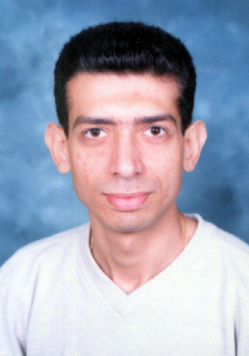
Name :Sheren Sameer Mosad
Date of Birth : 6 May , 1978
Place of Birth :Assuit, Egypt
Nationality :Egyptian
Social state : Married
Military Service: Exempted

Gender : Male

Education
B,Sc, commerce - accounting department
Assiut University, Assuit June 2003

Skills
*Microsoft office Applications professional
(Word –Int.Excel)
*Windows98, Windows Me ,Windows Xp and Windows2007
* Internet
*Experience in mobile phone maintenance
Experience Record
* Eighteen years and eight months as accountant at El Sharek Factory ( 1 / 9/ 2003 – 30/4/2022 )
* Ten months as supervisor at Somoha Acadmey
( 1 / 2/ 2007 - 31/12/2007)

*One year as supervisor at Pin code
( 1 /8 /2002 – 1 /8 /2003 )
*Three years as supervisor at Al Dawleya Co.
( 1 /7 /1999 – 1 /7 /2002 )

Languages
Arabic Native speaker
English Good
Address
14, Omer Ebn Abd Elaaziz st , Assuit / Egypt

Mob: 01221492924
01112252013
Email:shirysam5@gmail.com

