***Mariem Badr El Din Mohamed Mahmoud***

***Address : El Haram st, Mariotaya, Giza, Egypt.***

***Phone : 002- 01027329444 / 01026414181***

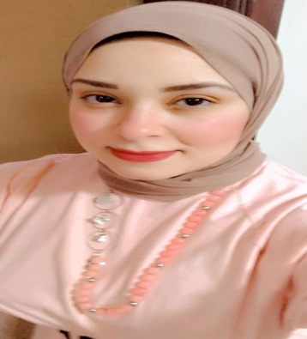***Date of birth : 03 / 10 /1990***

***Age : 31 Years Old***

***Objective:***

|  |
| --- |
| *Seeking a position where my educational and work experiences can be utilized and developed.* |

***Education/Degree:***

* *Bachelor of Law, Cairo University,2012.*

*Grade: Good.*

***Skills:***

***-Soft Skills.***

* *Working in a team work.*
* *Have the spirit of leading.*
* *Good in management work.*
* *Excellent communication skills.*
* *Ability to make fast and reliable decisions about how to solve  
   problems.*
* *Ability to work under pressure.*
* *Willing to learn new Technologies to be synchronized with the work.*

***-Computer Skills.***

* *Good Knowledge of internet tools, Microsoft Excel, Word, PowerPoint and Access.*

***-Language Skills.***

* *Native language Arabic.*
* *Very good command of both written and spoken English.*

***-Professional Experience:***

***Training:***

* *English Course at ASSEB Academy.*

***Work Experience****:*

* *Working in Etisalat Company for Communication in CASH Collection department for two years.*
* *Working in Vodafone Company in Sales and Customer service department since Four years* ***“Current Job till now”***

***Hobbies: -***

* *Reading.*
* *Computer.*

***Thanks for giving me the opportunity.***