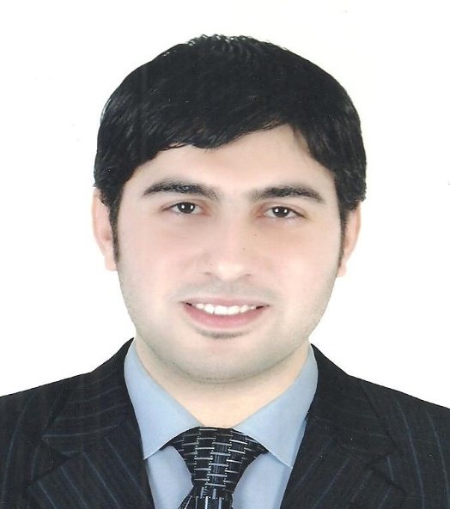

**Education**

* **Bachelor of Arts Department of Media**

**Division of Journalism 2008**

**Skills**

|  |  |
| --- | --- |
| * **Top research and investigative skills with excellent attention to detail and observational ability and a talent for finding obscure information.** * **Motivated self-starter and highly skilled creative thinker, which gives me the tools to stay focused on an assignment and see it from a new perspective** * **Strong computer proficiency in most major software programs and social media platforms that are used by writers and journalists, like Word ,Word Press, and Facebook.** * **I had great experience as an online journalist since 2014, and I was able to formulate professional press news content, that adheres to credibility and modern technical standards such as SEO, with the full ability to deal with the SEO Yoast and Rank Math tools found in Word Press** |  |

**Experience**

* **Media researcher at The United Company (Arabia Inform)**

**(from 10/2009 to 12/2010)**

* **Editing the TV news content and preparing it at a later stage for the preparation of research.**
* **Press Editor at Roayah News Network (from 2014 to 2022)**
* **Editing press and news content, in terms of bringing news from various Arab and foreign sources and specialized agencies such as Reuters, French, German and others.**
* **Preparing content-related press reports, as assigned by editorial directors, department heads, and chief executives.**
* **Preparing scripts for infographics or video graphics and submitting them to the graphic officials for implementation and publishing the videos on the official account of the site on YouTube**

**Courses**

* **I passed a course in journalistic editing from one of the major national newspapers in Egypt in 2006 with a grade of very good.**
* **ICDL**
* **Experience certificate from the United Company (Arabia Info) for the period of work as a media researcher there.**



Hossam Eldin ElSobky

**Contact**

**Phone:**

**01009228373**

**Email:**

**seif_elislam_2010@yahoo.com**