Mahmoud Refaat

**Computer Maintenance &**

**Networking Technician**

**CONTACT INFO**

01202150648

Abdulrahman st, Helwan

[mahmouedrafatt16@gmail.com](mailto:mahmouedrafatt16@gmail.com)

**ABOUT ME,**

Computer Technician experienced in repairing computer hardware and diagnosing and resolving network and software issues.

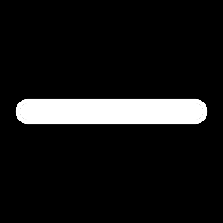

**SKILLS**

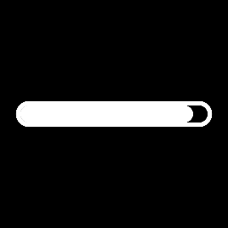Computer Maintenance

Software

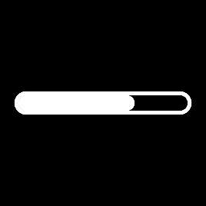Hardware

Computer Skills

Microsoft Office

**EDUCATION**

Diploma in Commerce, Insurance Section (2015/2016)

**COURCES**

* Motherboard Maintenance Training at EGY4TEC (Very Good)
* Laptop Maintenance Training at EGY4TEC (Excellent)

**WORK EXPERIENCE**

**2016-2017**

**Maintenance technician assistant**

Started my Career as a trainee at Soft Click First co. for nearly 9 Months.

**2017-2018**

**Maintenance and installation technician**

Worked as Maintenance and installation technician at Infinity co. for One Year.

**2018-2020**

**Freelance Maintenance and installation technician**

Worked as an on demand Maintenance and Networking technician During my time in Military Service.

**2020-2021**

**Maintenance and installation technician**

Worked as Maintenance and installation technician at Etisalat eg for Nearly 6 Months.