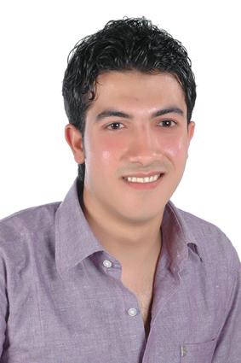Curriculum Vitae

Personal Data:

|  |  |
| --- | --- |
| **Name** | : Mohamed Ahmed Gomaa Teleb |
| **Date of birth** | : 6/2/1988 |
| **Place of birth** | : Alexandria. |
| **Address** | : Abn Shaltot st bahary,separate from Malk Hafnny, from 45st,home no10 , Alexandria,Egypt. |
| **Marital status** | : Married. |
| **Military status** | : Final Exemption |
| **Phone** | : 01283140153 |
| **E-Mail** | : [gomaamo020@gmail.com](mailto:gomaamo020@gmail.com) |
| **Nationality** | :Egyptian |

Education:

* Bachelor of Quality Control
* Graduation Date: 2009
* General Grade : Good.
* Industrial technical institute service and Repairing Car Mechanic Department.

Languages skills:

* Arabic : Mother Tongue.
* English : Fluent Spoken and written ( General English Courses reaching level Six & still in process)

Computer Skills:

* ICDL Course from UNESCO with UN no :11010855
* Accounting Courses: Advanced Excel -Commercial Excel -Quick Books -Peach Tree

Experiences:

* Worked in Maintenance car center for two years.
* Working for the summer time at the automobile & tourism club since 2001.
* Working at Engineering company for Auto industry (Al Nasr company previously) - Diagnosis device malfunction & Technical research specialist.

Personal Skills:

* Driving Skills (Having my own personal driving license).
* Ability to work under stress & under any circumstances.
* Knowing how to work within a team group & can fit in.
* Fast learning & interested for learning more.

(Documents & references will be presented upon request)