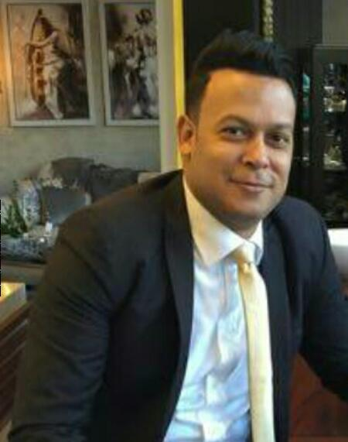**Mob. :** 01090003335

**Address :**  
**Cairo Gardens 6th Of October City 8th District Building 3 Flat 205**

**Email** : ***[haythamahmed094@gmail.com](mailto:haythamahmed094@gmail.com)***

***Haitham abd elgaffar abd elshkour gabala***

|  |  |
| --- | --- |
| Personal Information | * ***Marital status : married*** * ***Place of Birth : Cairo, Egypt*** * ***Nationality : Egyptian*** * ***Date Of Birth : 20/11/1984*** * ***Military status : completed*** * ***Religion : Moslem*** |
| Objective | **● Director of Ceramics and Sanitaryware Exhibition** |
| Education | ***Institute of Systems and Information***  ***Grade: good*** |
| Work Experience | ● **Director of Ahmed Al Sallab Exhibition for Ceramics and Sanitaryware from**   * ***Training courses in gemma factory from 2008 to 2018***   **. *Hold* drills (Skills of communication _ Customer Service _ Preparing leaders - Selling skill_ Marketing).Leadership Training Course**  **Accredited from Ain Shams University**   * ***Training courses in Royal factory 2008*** * ***Training courses in Celopatra factory 2009*** * ***Training courses in Ideal standard factory 2010*** * ***Training courses in Roca factory 2012*** * ***Training at polena mall in Italy 2014*** * ***Training at Valencia mall in Spain 2015*** * ***Holds first place in the sales at the branch level in the Engineer Ahmed Sallab company from 2008 to 2014*** |
| Language Skills | * ***Good command of English .*** * ***Arabic, Mother Tongue.*** |
| Computer Skills | * ***Microsoft® Windows 98/ 2000 / Xp / Me / vista / windows 7*** * ***Microsoft Office*** * ***Good experience in using Microsoft Word Xp,2003*** * ***Familiar with using Microsoft Outlook Xp,2003*** * ***Excellent Experience in Surfing The Internet and ability to perform Products and services Researches*** * ***ICDL*** |
| **Personal Skills** | * ***Ability to learn quickly*** * ***Hard Worker*** * ***Highly reliable*** * ***Ability to work independentl*** * ***Ability to work in a dynamic environment*** * ***Organization & coordination*** * ***Self dependent.*** * ***Self motivated*** * ***Fully looking forward to continuously develop My Skills.*** |
| **Business & Management Skills** | * ***Ability to work under pressure and meet deadlines.*** * ***Ability to work with others towards a team concept Developing idea.*** |