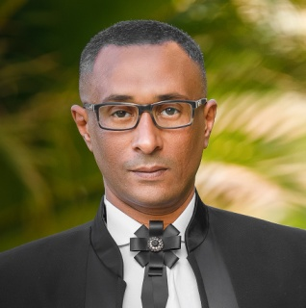**MOHAMED Hussien Mahmoud**

**ELNOZHA ELGEDIDA**

**Cairo. Egypt**

**Telephone: 0221823094**

**Mobile 01000464002**

**E-mail:** [**kajooo259@gmail.com**](mailto:kajooo259@gmail.com)

**OBJECTIVE**

**Seeking a job in the field at your organization where my background and experience can be well utilized.**

**EDUCATOIN**

**BSC Management Information system - 2007**

**General Grade: Good**

**Integrated Thebes Academy**

**PERSONAL INFORMATION_____________________________________________**

**Date of Birth: 25-09-1983**

**MARTIAL STATUS: Married**

**Military Status: Exempted**

**Nationality : Egyptian**

**Certificates**

* **Rescue roles and Preparation of teacher**
* **From Guinness Book - Rotary club for breaking the world record for most people swimming at the same time anywhere.**
* **ICDL**
* **English language**

**EXPERIENCE**

**1- Tour leader & reservation in "Blue Coast Tours" (2 years)**

**2- Customer Service in "VODAFONE" (3 years)**

**3- Sales Representative in "Soficopharm" (7 years)**

**4- Control and Loading operation team leader UNITED GROUP NISSAN DEALER (5 years)**

**\*\* Swimming Coach in "GHABA CLUB-SMASH CLUB-ETHAD ELSHORTA CLUB" (12 YEARS)\*\***

**Computer skills:**

**-Excellent Knowledge of windows and Internet**

**Very good Knowledge of word and Excel-**

**-Good Knowledge of Access, excel, PowerPoint and Outlook.**

**-Good working in electronics and hardware maintenance.**

**Language Skills**

**Native Language Arabic-**

**Very Good command of written English and good in spoken English.-**

**INTERESTS**

**1- Swimming**

**2-Music**

**3-Traveling**

**4-Reading**

**ABILITES**

**1-Work with team**

**2-Work under pressure**

**3-Work over 8 hour**