
Muhammad Abbas Sarhan Mahmoud
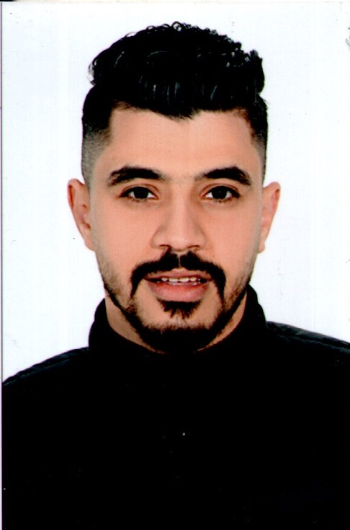
Date of Birth: 11/15/1993
Address: El Tebeen - Cairo – Egypt.
National Number: 293111150103732
Military service: set a good example.

: (002) 01111208698
e-mail : mohamed151193abbas@gmail.com

Education ________________________________________
• Bachelor of Quality Control Specialist
• Year of Graduation: 2017
• good MARK
Experience_____________________________________
- • Worked in the Resala Foundation for Business from 2015 to 2017
• Worked at Menlo Company, the agency of Brown Personal Care, from 2017 to 2018
• Work in Samir William Company for Personal Care Supplies from 2018 to 2022.
Skills_____________________________________

Computer Skills:

- Excellent knowledge of computer basics.
- Good knowledge of Word – Excel .
Language Skills:
■ Native language Arabic
■ language English
Good command of both written and spoken English.

Personal Skills:
•Ease of communication with others
• Forming a work team
• Collaboration and adaptation with the work team
• work under pressure
• Achieving the desired personal target
• Continue the success of the system
• Movement between sections within the system

Thanks for Your Precious Time
I Will Be Honoured To Join Your Successful Team Work

