**Esraa Saber El Said Shalkamy**

e-mail: [esraasaber074@gmail.com](mailto:esraasaber074@gmail.com)

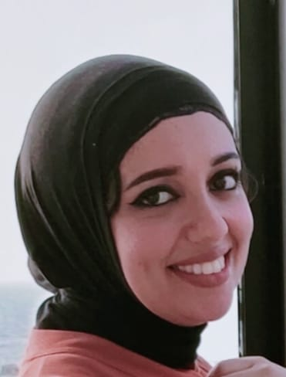

**Personal information:**

**Age: 31**

**Date of birth**

**8\3\1992**

**Phone number:** **01202542531**

**Hobbies:**

**Drawing, Reading and Doing sports**

**Profession summary:**

**Creative and motivated Artist with progressive career**

**experience in various forms of structure and design.**

**Known for strengths project design, planning and**

**management to exceed customer expectations**

**Education**

**Bachelor from Faculty of Fine Arts Painting department in 2014**

**Master Degree holder in 2020.**

**: Work History**

**Drawing some paintings from other authentic Artists as a copy.**

**Drawing on the walls in a private gallery.**

**Teaching drawing courses at Faculty of Fine Arts and other centers**

**Took part in many galleries.**

**Courses:**

**English at the British council**

**Photoshop and One Design**

**Skills:**

**Concept Art**

**Composition**

**Design principle**

**Adobe Creative suite (Photoshop & InDesign)**

**Team management**

**Exhibition Design**

**Some of my work:**

