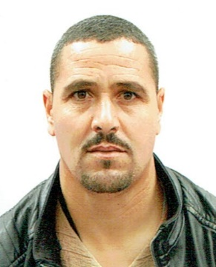

**TAYEBI ABDALLAH**

**EDUCATION**

**certificate of professional qualification**

**electrofusion and butt welding**

**by polyte chemical training school ( BATNA )**

**IN 20/01/2016**

**PROFILE**

**fusion diploma**

**control on polyethylene**

**by SONELGAZ IN 10/05/2016**

**I holds many certifications**

**Keen to find a challenging position with in an exciting employer where I will be able to continue to increase my work experience & develop my abilities.**

**Vocational qualification certificate**

**installation of drainage and pumping supply network**

**by Vocational training center and apprenticeship**

**IN 23/07/2022**

**CONTACT**

391-mail4.png

**Abdallahtaybi27@gmail.com**

067-phone.png

**EXPERIENCE**

**+213 5 42 19 90 18**

**+213 7 71 27 88 38**

001-home.png

* **06 years in SARL MMTBB**

**in position :merger**

* **01 year in STRAFID SEDDIKI**

**in position :merger**

* **06 years in SARL TM REBIHI**

**in position :merger**

* **01 year in SARL TM REBIHI**

**in position :** **Head site**

* **09 years driver**

**BELDJE village municipality KSOUR**

202-sphere.png

**driving license : B**



**Exempt from national service**

**Date and place of birth : 23/02/1982 / El Hamadia**

**Langues**

**SKILLS**

032-book.png

**- Good skill in using various welding tools.**

**- Manual labor skills**

**- Creative skills/design skills**

**- Strong physical skills to stand for long -hours while working**

**- The ability to work in an environment full of noise and noise**

**-Familiarity with public safety policies**

**- Precision and attention to detail**

Arabe

032-book.png032-book.png

Français

Anglais