curriculum vitae

Omnia Reda abdulfatah

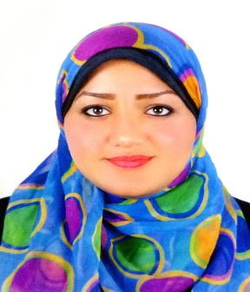
Objectives:
- Seeking an opportunity where I can benefit from my study, language capabilities, experiences and personal skills as a chance to develop professional growth and personal experience from such participation.

Personal Information:
- Nationality: Egyptian.
- Date of birth: 13th of September, 1993.
- Address: 26 Alkholafaa Elrashdeen St, El Haram, Giza.
- Social status: Single.
- Phone: 0233628400
- Mobile: 01159777236 - 01013948694
- E-mail: omniareda400@gmail.com
Education:
- Qualification: Higher Institute
- Department: Graphic
- University: Faculty of Technology of Ain Shams University
- General grade: good
- Year of graduation: 2013
Language skills:
- Native language Arabic
- good English.

Experience:
- From October 2013 to June 2014 “Royal for Natural Herbs Company”
  - Secretary.

- From November 2014 to November 2016 “Ahmos Language School”

  - Computer teacher.

- From January 2017 to February 2018 “El-Zienah Company for Supply”
  - Director of the Office.
- From October 2017 to April 2018 “El-Salwa Center”

  - Executive secretary and a sales manager.
- From June 2018 to May 2019 “El-Nour for cars”

  - Executive secretary.
Personal skills:
- Excellent communication skills.
- Very good presentation skills.
- Ability to work under pressure.
- Ability to learn new tasks according to job requirements.
- Ability to work individual or as a team member.
- Customer service.
- Time management & decision maker.
- Reporting.
- writing professional E mails.
- Organization of meetings.
- Very good in sales.
- Online ads

Computer skills:
- Very good dealing with Microsoft windows.
- Excellent with internet applications.
- Very good dealing with Microsoft office programs.

