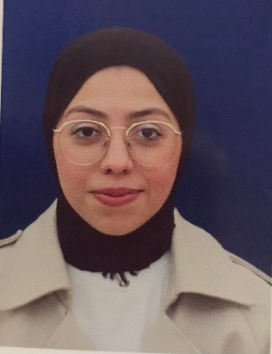

(+972) 597319221 | [woroodqandeel2018@gmail.com](mailto:woroodqandeel2018@gmail.com)

| **Address**: Ţulkarm, Palestine

**Birthday**: 2/9/2000

| **Nationality:** Palestinian

| Gender: Female

**Worood Qandeel**

**Education**

BA in Construction Engineering, [Palestine Technology/Khadouri], [Ţulkarm], [Palestine]

©AZURIUS – Modeles-de-cv,com

September [2018] - June [2023]

**Languages**

Arabic (native)

English (very good)

Turkish (elementary)

**Skills**

* Microsoft office
* Google Analytics, Google AdWords, Facebook Ads
* Good communication skills
* Project management
* Leadership
* Typing and data entry

**Experience and Certificates**

* 12/2/2018 certificates for " Computer maintenance"
* 18/2/2018 Computer networking training.
* 1/10/2020 certificates for " Autodesk AutoCAD"
* 22/9/2021 certificates for " 3D max"
* 22/9/2021 Sales representative at Al-Hayat Foundation
* 10/12/2023 Training in an engineering office
* 24/12/2023 certificates for " Revit "
* 2/11/2023 Field training in the Ţulkarm municipality

**Hobbies and interests**

* Passionate about traveling and discovering new cultures and enjoy exploring new places to broaden my horizons.
* I would describe myself as an ambitious visionary who work hard to achieve my goals.