# *Curriculum Vitae*

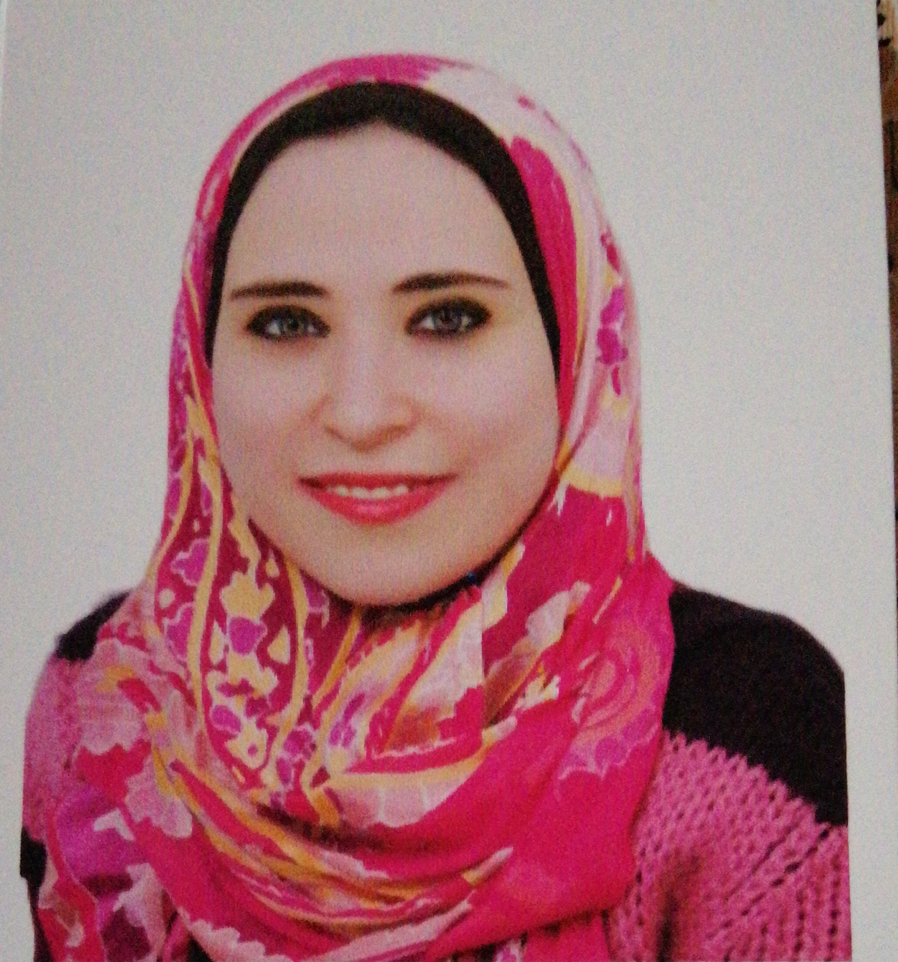

# *Personal information:-*

**Name** : Nermeen Maher Mohamed Musilhy

**Nationality** : Egyptian

**Religion** : Muslim

**Social Status**: Married

**Date of Birth**: 12/2/1989

**Place of Birth**: Cairo

**Place of Residence**: 61Manshit elTharir GesrELSwiss

***Mobile Number****: 01002946055*

**E-mail**: nerymaher06@gmail.com

# *Education:-*

Name of School :OM Kolthoum Language School

**Name of university**: Akhbar El Yom Academy

**Major**: Bachelor of Media

**Minor**: Department of Journalism

**GPA**: Very good condition with honors

**Year**: May 2011

# *Language:-*

**English Language**: Very good

***Training Courses:-***

**\* Training in the SIS for the Ministry of Information in the editing and translation**

***\**Training in the editing and translation of press agency MENA news**

***\**ICDL course University of Cambridge, UK**

***\*English Course at concept Professional Solutions***