
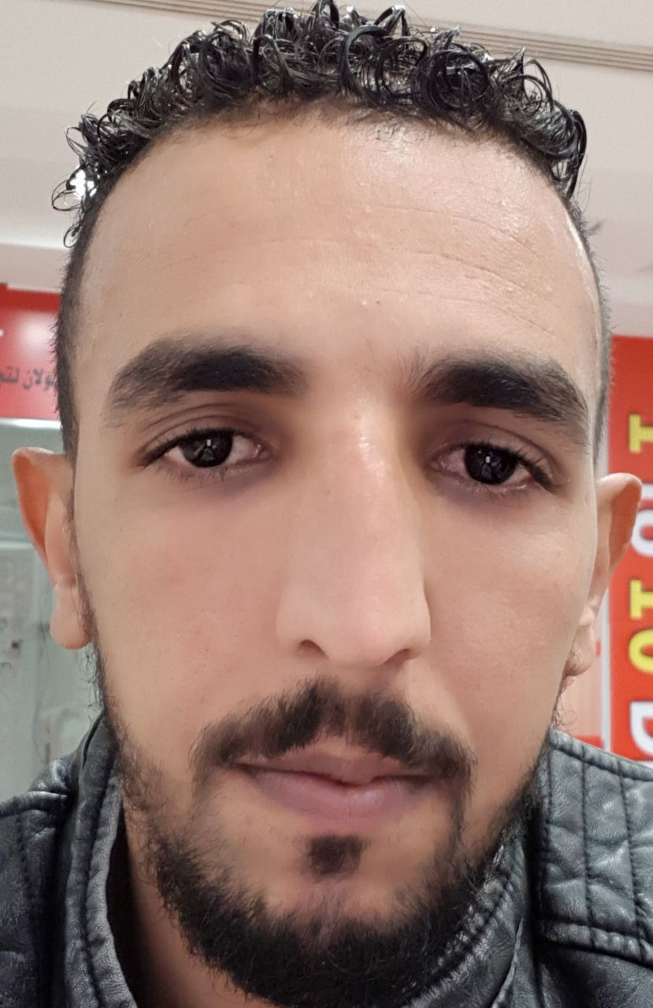
Noreddine JANAH
Address:
City- Country: Sidi Jabber, Beni Mellal MOROCCO
Phone Number: +971507765773
Date and place of birth: 21/10/1985 in Sidi Jabber BENI MELLAL
Family status: Single
Nationality: MOROCCAN
E-mail:
ACADEMIC QUALIFICATIONS

2015 - 2016 : Diploma of Technician in Mechanical Manufacturing
2013 - 2014 : Diploma of Qualification in General Mechanics
02/05/2016 - 31/05/2016 : Internship at the factory of sugar and refinery (SUTA) MOROCCO
PROFESSIONAL EXPERIENCES
05/2015 – 05/2017 : Driver of the agricultural machinery and transport of food products
COMPETENCIES DOMAINS
Computing skills:

- Office tools: (Word- Excel- PowerPoint)

Language:

- Arabic: Mother Tongue
- French: Advanced
- English: Intermediate
HOBBIES AND INTERESTS

- Sports : basketball, swimming, fitness.
- Voyages : traveling and discovering new places.
- Other : Reading and writing, teamwork.

