**Curriculum Vitae**

**It's an honor for me to introduce this C.V. with my personal information to apply to work in your group as an employee contributing in the development of this corporation.**

**Personal Information**

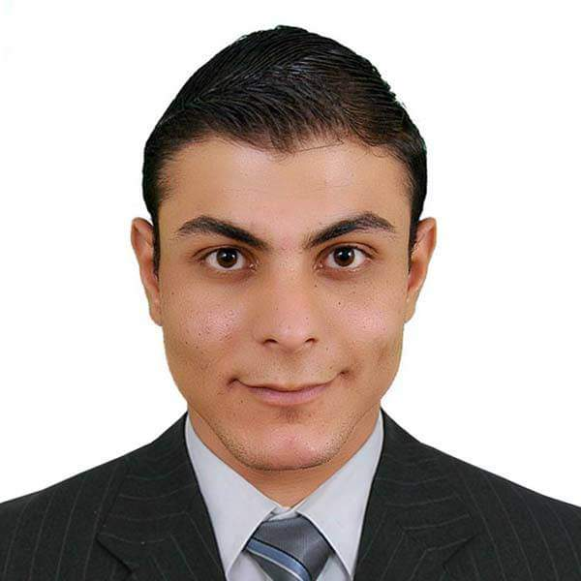

Name : AHMED SAID ISMAIL

Nationality : Egyptian

Date of Birth 1993.4.12

Place of Birth :Tukh - Qaliobeya

Marital Status :single

Military Status : Performed military service

**Contact Details**

E-Mail : cpahmed12@gmail.com

Mob : 0547428802

Address: Al-DMMAM , Al-FAISALIYAH , Saudi Arabia

**Objective**

I do not care I will work in a large or small organization, but what concerns me is the relationship my colleagues at work and apply everything they are asking me to my superiors at work

**Education**

Faculty of Physical Education.. Education of sports school section

Graduation year: May 2015

Graduation grade: good

**Languages**

English : good

Arabic : Mother tongue

**Computer Skills**

- Operating systems Windows (xp, win7,win8, win10)

- Software Microsoft office (xp,2007,2010)

- Internet All internet applications

**Typing Skills**

Very good skills in typing for both English & Arabic

**Work Experience**

Work in :

* Sports traininning in katamaya garden in Egypt from 2013 to 2014 .
* Work as a seller in a ceramic exhibition in Al-Ahsa for 8 months
* Data entry for gulf arc company for 6 months
* A sales representative in the Eastern Province has been working for the Reda Al-Attiyah warehouse in Al-Ahsa for a year on the Hajar and Al-Majlous Dispensary and Al-Huda Tribune
* I have a Saudi driving license

**Training & other courses**

* Lifesaving course (certificated)

**Previous activities:**

-Practical training in Ministry of Education schools (certificated)

-Scientific Conference for Sports Training and Movement Science (certificated)

**Mastering the work of :**

1 - Gymnastics

2 – Swimming

3 - Rescue