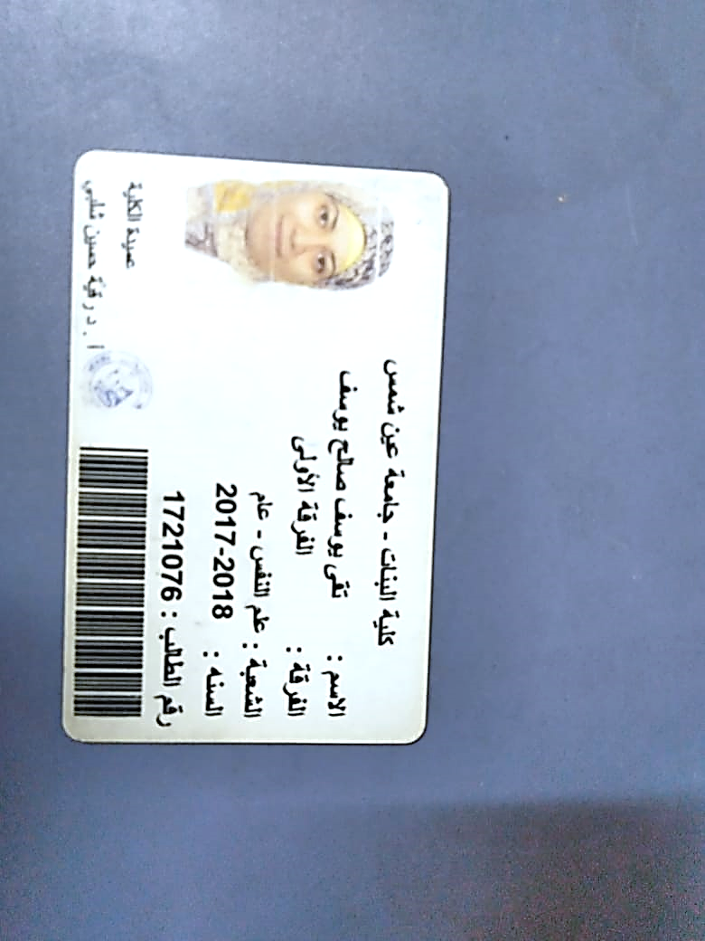 **C V**

**Personal information :**

**Name :** toka youssef saleh **Marital state :** single

**Date of birth :** 24/7/1999 **Nationality :** egyptian

**Current address :** 9 ahmed mazen street – ard al-liwaa**-** mohandessin - agouza department - giza

**Telephone number :** 01143693114

**Email address :** toka youssef 528 @ gmail.com

**Education & Qualifications :**

I have a bachelor's degree in psychology from faculty of arts girls, ain shams in (may 2020/2021)

**Languages :**

**Arabic:** mother language

**English :** good comm and in speaking , reading and writing

**Working experience :**

Secretary in a law firm from (2020 to 2021 )

**Courses :**

**English** : I have a certificate from british foundation

**ICDL :** I have a degree from the Faculty of Computers and artificial intelligence , Cairo University during from ( 3/11/2021 to 24/11/2021 )

**H R :** I have a certificate from the American Institute of Human Resources HRCI

**Activities & Voluntary :**

Contributed to a literacy project for adult education

**Sterengths and skills :**

Good at using the computer

Full adaptation to work within the work team

Ability to perform under work pressure

Quick to find ways to solve problems