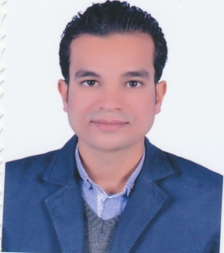**Curriculum vitae**

|  |  |  |
| --- | --- | --- |
| **personal information** | | |
| Mahmoud Ahmed Aboelmagd Omran | | Name |
| Egyptian | | Nationality |
| Muslim | | Religion |
| 10/5/1989 | | Date of Birth |
| ElAraky - Farshout - QENA - EGYPT | | Address |
| HOME : +20966660004 | Mobile:+201005740314 | Phone |
| Married + 3 | | Social status |
| Final exemption from conscription | | The position of the recruitmen |
| Mahmoudaboelmagd03@gmail.com | | e-mail |
|  | |  |
|  | |  |
| **Overall Assessment** | | **Qualifications** |
| Very good | | Bachelor of Physical Education 2010 |
| good | | Bachelor of Law 2016 |
|  | |  |
|  | |  |
| **Languages** | | |
| Arabic | | |
| English | | |
|  | |  |
|  | |  |
| **Practical experiences** | | |
| Drilling worker at Shelf Drilling Company in Egypt | | |
| Physical education teacher at the Egyptian Ministry of Education | | |
|  | |  |
|  | |  |
| **Scientific sessions** | | |
| Get International Certificate Computer Driving ICDL fifth edition | | |
| get special courses from The Ministry of Education | | |
|  | | |
| **Skills** | | |
| Proficiency in Computer Skills Proficiency | | |
| Proficiency in speaking and writing in English | | |
| Ability to leadership, management and organization | | |
| Ability to organize activities and recreational sports and competitions | | |
| The ability to perform calculations and digital operations | | |
| Ability to take responsibility and work pressure | | |
| The fruitful cooperation with colleagues and achieve the best results at work | | |
| the ability to deal with others in different circumstances | | |
| Proficiency in dealing with all Alsocheal Media programs | | |