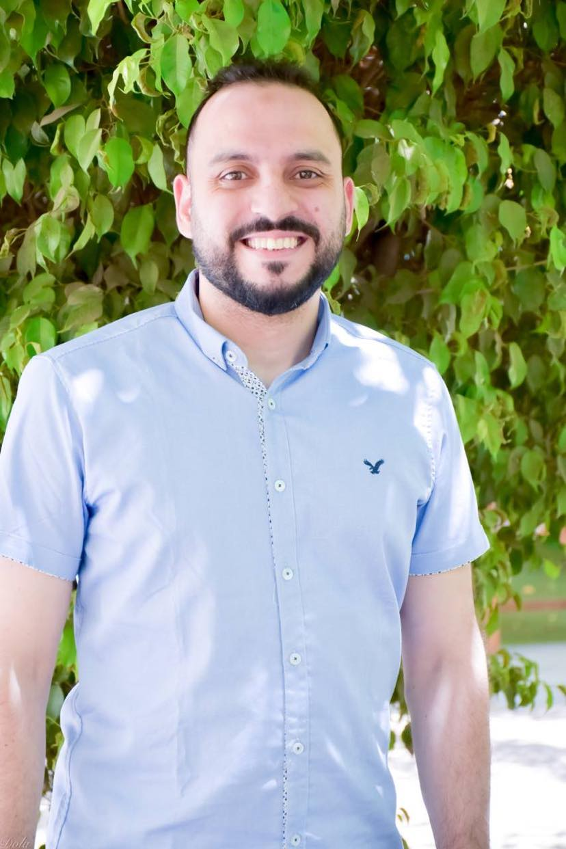

Mohamed Salem Mohamed Elsherbiny

19 Shawky Habib st, Omrania,Giza,Egypt

Mobile: (02) 01099909884 – 01153975539

E-mail: : M.Salem0027@gmail.com

objective
Seeking for challenging job opportunity depending on my good teaching, Interacting experience, creative spirit & development talents in a progressive and ambitious environment.

education
Master's degree MBA
I passed the first year of the MBA course

Faculty of Commerce, Accounting Department Grade: Good
Cairo University Graduation Year : 2009

skills
Computer Skills: ICDL course from Russian Cultural Center.

English course at Russian Cultural Center.

Certified course in Customer Service and Preparing professional sales representative from The camecenter

Experience
- Work at Sigma Lab for Rays and Medical test as a Branchs administrative manager and Accountant from 2014 till Now.

- Work at I.T.I Company as an Accountant from 2013 till 2014.

- Work for Pharmaceutical Company Called Egyptian Promoters Center in Customers Accounts Department from 2012 till 2013.

- Work at Etisalat Company as a representative of customer service from 2011 till 2012.

- Work at El-Shabrawy Office for Accounting and Auditing from 2009 until 2011.

- Summer Training in National Bank of Egypt (2007 and 2009).

Interests and personal skills
1-SOFT SKILLS:
- Communication skills.
- Presentation skills.
- Negotiation skills
- Persuasion skills.
- High ability to learn.
- Good ability to work under pressure.

2-Interests:
Reading, , Learning courses , practicing sport

Personal Information
Date of Birth: 4/6/1988
Marital Status: separate and I have a daughter
Military Status: final exemption from military service

