ramy khamis ibrahem kotp
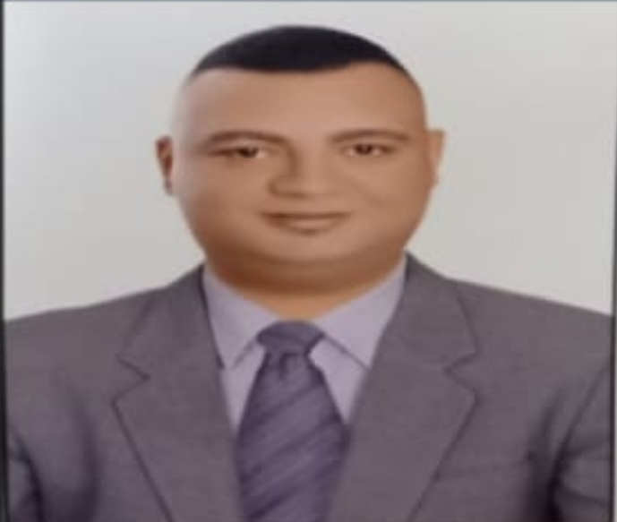
Contact Information

Adders: Alexandria- Egypt

Age: (37) (15-7-1985)

Phone: +201286222950

Mail ibrahemkotp12@gmail.com

Objective:

Seeking a permanent challenging position that matches my ambitious and motivated personality to improve my skills and utilize my qualifications as well.

Education:

Industrial schools

Graduation year: 2003

Languages:

Arabic: Mother tongue

English: Good (reading_ writing and speaking)

Training:

- Training in Haccp.
- Food safety regulations
- Food quality control
- Management and organization
- Quality communication management

Work Experience:

- Melodies Restaurant in Sharm El sheikh wietar (2004- 2006)

- Melodies Restaurant in Cairo capaion (2006- 2009)

- Makani Restaurant shift leader (2009 – 2011)
- IL gusto Restaurant Restaurant assistant director (2011 – 2013)

- Olives Restaurant senior caption ( 2014 - 2016 )

- Buffalo burger restaurant assistant director (2016-2018)

- flames restaurants operation manager (2018-2021)

- buonpasto restaurants operation manager (2021-2022)

Computer Skills:

Good User of
- Word
- Excel
- Internet

Personal Skills:
- Team working and Follow up team work.
- How to handle complain.
- Ability of working under pressure.
- Creative & perfect listening skills.
- Good communication skills & eager to learn

Thank you for your time reading my C.V

