Aly Ahmed Aly Abou Aly

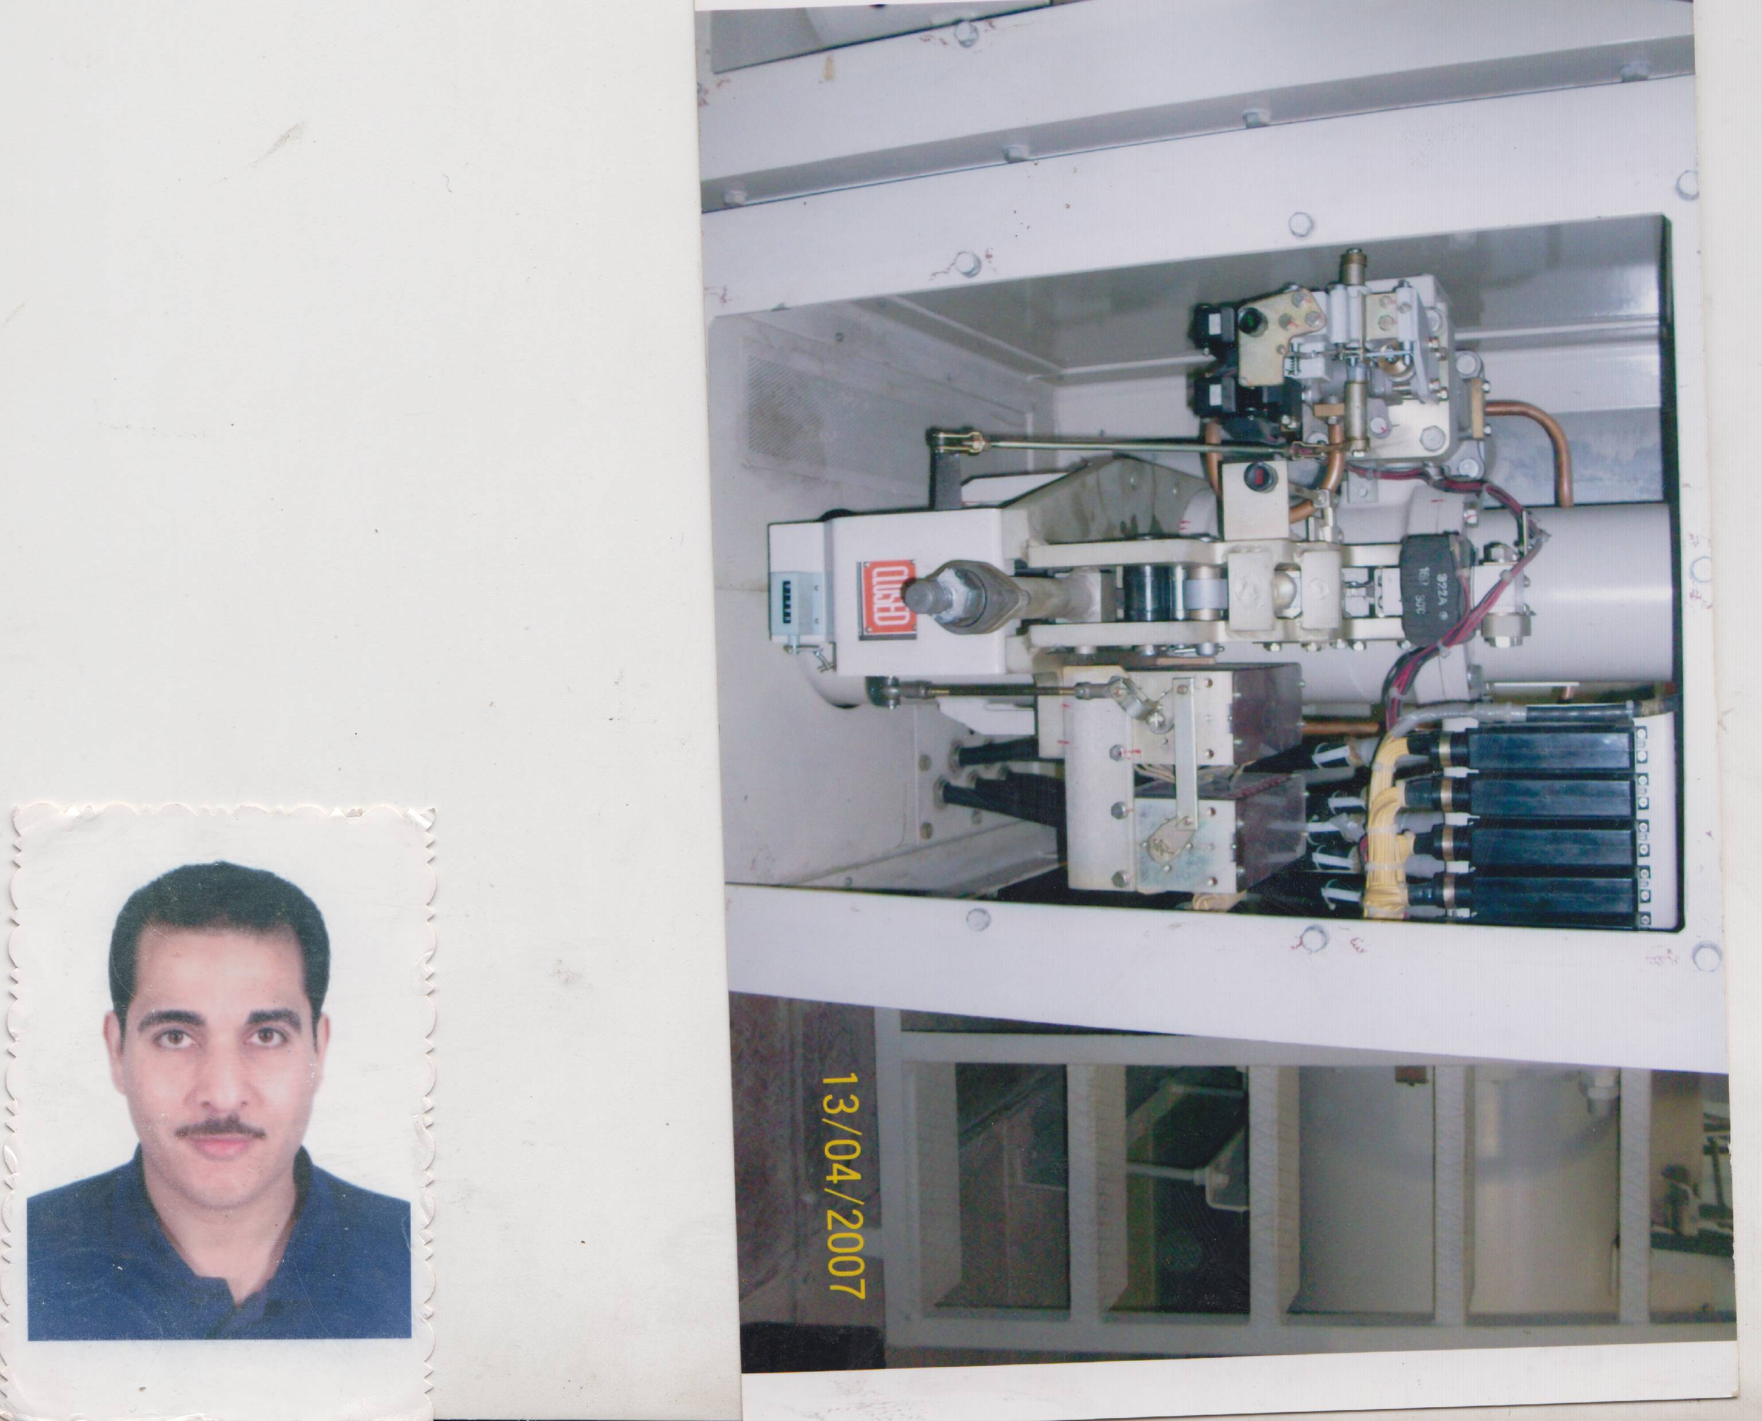

Address : El-Naseria,El-Fath, Assiut, Egypt.
Mobile : 002 /01149311345
Email : engaly5062@yahoo.com
Data of Birth : 26/4/1981
Social Case : Married
PassPort Number : A30540441
Profession in Passport Number : General Manager

:

Education:

* Electric Engineering Bachelor (2003) in Assiut University (Power & Eictric Machine).
* Grade : Good.
* Diploma In Electrical Engineeing (2006) in Assiut University (Power & Eictric Machine) .
* Grade : Good.
*Certificate from HITACHI Company"Supervisor of HITACHI "
*Certificate from ABB Company for support in installation equipment GIS for 550 & 220 KV .
Skills:

- Computer Skills:
- Good Knowledge of (Ms.Office – Ms. Windows –Matlab-Fortran).
- Language Skill:
- Native language Arabic.
- Good command of both written and spoken English.
- Personal Skills:
- Ability to work under pressure.
- Ability to work with all levels of management and personnel.
- Ability to merge into new communities and life style.
- Patient, ambitious and high self-motivated.
- Must have thorough knowledge of safety (operation) rules and regulation and safety operation procedure with direct involvement and participating.
- Should have innovative and modest approach to carry out the job and responsibility.
and have command and fluency on English language to communicate and prepare draft and reports.

Experiences:

In Egyptian Company for Electricity Transmission from 2 / 2005 till now, More than 18 years exp. :

1) Seven Years Experience in carrying out control and operations of all equipments at 220/66/11 KV level Substations ( In Egyptian Electric Holding Com).

2) More than nine years of experience working as a maintenance engineer in the Egyptian Company for Electricity Transmission ( Assuit 500 kV substation GIS 500/220/132/66/33/11 kV " HITACHI Company"):
- independently maintaining / trouble shooting for all electrical , Mechanical defects / faults . 500 KV, 220 KV , 132 KV ,66 KV, 33 KV, 11 kV , Fire Fighting System .Prepare maintenance schedules and maintenance procedure Petrolling , inspection and Ordinary inspection Site hand works for all types of maintenance and clarifying all defects / faults . I have a certificate " as Supervisor of Hittachi " after solving problem in DS Bus-Bar .
- Review of DRW designed for the construction and installation of electrically insulated gas station (GIS) .
3) More than one year of experience working as a general manager in the Egyptian Company for Electricity Transmission ( Assuit 500 kV and East substation GIS 500/220/132/66/33/11 kV ) .

