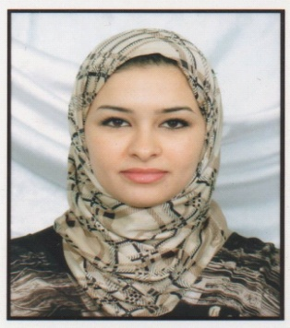

**SELLAI RADHIA**

Travessa Dos Pasteleiros N°9,01 ESQ, Santarém

+351920045488

[Radia25sellai@gmail.com](mailto:Radia25sellai@gmail.com)

WhatsApp +351920045488

07/05/1986 in Constantine. Algeria

Maried (Mother of one kid)

**PROFESSIONELLE EXPERIENCE**

**07/09/2020-till now :** Customer service representative

* Global Shares – Lisbon- Portugal

**14/12/2014- 15/07/2019 :** Telephone operator

* Diphaco -Constantine- Algeria

**09/09/2013- 21/08/2014 :** Telephone operator

* Zedpharm- Constantine- Algeria

**15/04/2012- 30/06/2013 :** TemporaryEnglish Professor

* University –Mentouri- of Constantine. Algeria

**23/02/2012- 30/06/2013 :** TemporaryEnglish Professor

* University -Mentouri -of Constantine. Algeria

**TRAINEESHIPS**

**17/03/2009- 20/09/2009** **:** Traineeship

* National Bank of Algeria (BNA)

**23/02/2009- 25/08/2009 :** Traineeship

* External Bank of Algeria (BEA)

**STUDY AND FORMATIONS**

**2005 – 2009:** College graduated in Economic science (BAC+4) option:

Money Bank and Finance (MBF).

* **University –Mentouri- of Constantine- Departement of economic science. Algeria**

**2006 – 2012:** Master degree in English (BAC+5) option: Applied Languages (LA).

* **University- Mentouri - of Constantine- Departement of Lettres and foreign Languages. Algeria**

**2008 – 2009:** Certificat in Data processing. Option: office computing

* **Centre Boudjriou of Constantine.Algeria**

**LANGUAGES**

* Arabic : Mother Language.
* Français : Good.
* Anglais : Good – Vacation Certificate– University- Mentouri -of Constantine. Algeria

**OTHER QUALIFICATIONS**

* Good Computer Skills – Office computing: Microsoft Office and Internet.
* Worked on: jira and confluence, Divalto, intellix, compiere.
* Licence driver: category B.

**OTHERS**

* Serious
* Respect and ease of communication
* Ease of adaptation, learning and assimilation
* Sens of organisation and responsability
* Team spirit
* Motivated
* Dynamic and sociable