Curriculum Vitae
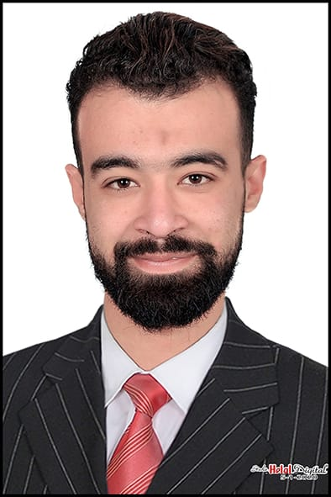
Personal Information’s:
Name: Ahmed Mohsen Abd Elhamed.
Marital Status: Single.
Birth Date: 28-07-1994
Place of Birth: Damietta, Egypt.
Nationality: Egyptian.
Contacts:
Mobile No. : 01062628717
E-Mail : ahmed94mohsen@yahoo.com
------------------------------------------------------------------------------------------------------------------
Educational Qualifications:
- Bachelor Degree of Art Education Division (2014-2019).
Faculty of Specific Education – Damietta University.
Courses and Certificates:
- Aups Scholarship English Elementary Level (4, 5, 6&7) (Certified).
- Soft Skills (Certified).
- ICDL (Certified).
All at American University of Professional Studies A.U.P.S
AUPS Continuing Education Center (CEC)
To confirm certificate visit: www.aups-edu.us serial number: AUPSCER1910078124IG
- Graduated from an accounting course
- Graduated from a human development course
------------------------------------------------------------------------------------------------------------------
Work In:
- Worked in trade and distribution with 5 years of experience
- Worked in Mac United Company for Trade and Tenders, two years experience
- Worked in decoration and gypsum board, 4 years of experience
- Worked for Fawzi Al-Rifai Company in road and bridge contracting, 6 months experience
- Worked at Overseas Customs Clearance Company for 6 months in Damietta Port

Personal Skills:
1) Perfect with Computer Programs like Microsoft (Word, Excel, and PowerPoint).
2) Excellent written and verbal communication skills.
3) Ability to work independently or as part of a team.
4) Highly organized and efficient.
5) Presentation skills.
6) Fast learner.
7) Work under Pressure.
------------------------------------------------------------------------------------------------------------------
Interests:
1) Accountings.
2) Other cultures.

