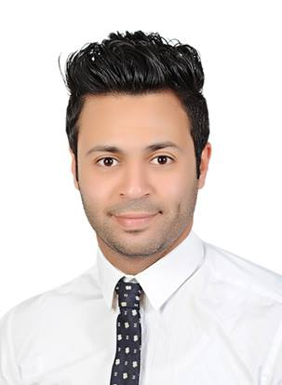

**Mohamed Tarek Mohamed**

**”Fasiel” - Giza- Egypt**

**Mobile: 01141150892**

**Email:tarekmohamed462@yahoo.com**

**Career Objective:**

* Seeking a dynamic position in the field of sales section where my skills and experiences can be well enhanced.

**Educational Background:**

* Helwan University, Faculty of commerce, 2009(account Section).

**Professional Experience: till now**

**_** Trainer perfume ,Makeup, Skin Care.

* **_store manager rdowan alogail “Diverso “for luxury Tie Guss watches and Tie ,accessories, wallets all Brand of perfumes, makeup, watches, Mont Blanc pens and wallet, accessories , Boss watches and Tie, pens, wallets, and others.**
* **sales manager at fashion district.**

**-sales rep group "Coty".**

**-assistant manager at loccitan.**

**- BA in all faces store.**

**- BA in all stores of local market in Egypt.**

**Date:** **April.2011 ــ till now**

**Position : Sales representative.**

**Company Name: MAC Egypt. “Manpower staff: 2500 employees”**

**Company Profile: Retail Filed**

**Section: SALES & marketing.**

**Responsibilities:**

* Drive customer service excellence to every aspect of the store, including store appearance, display of merchandise, product placement, story layout, and selling procedures.
* Ensure strategic goals and sales targets of the store are met by maximizing sales and gross profit, reviewing sales performance, controlling expenses.
* train, develop, and supervise staff.
* Provide staff with feedback, coaching, and performance evaluations.
* Coordinate daily staffing and staffing schedules.
* Ensure the store complies with outlined safety policies and procedures, as well as state and local health regulations.
* Perform administrative tasks to support the smooth operation of all store operations, including the timely submission of all personnel paperwork, preparing and submitting reports, and monitoring sales receipts and cash.
* Schedule and Perform regular field visits to manage stock coverage and place new orders.
* Follow up delivery process by communicating new orders to area manager to schedule products’ distribution and delivery to chains.

|  |  |
| --- | --- |
|  |  |

* Do a monthly target division on existing customers looking for new customers.

|  |  |
| --- | --- |
|  |  |
|  |  | * Follow-up sales within the shops and follow-up of those responsible for the sale. * Visit customers every day. * Reports on product status per week, monthly and annually. * Identification and inventory of slow items and work on the speed of sale. * Follow-up sales people in the shops and evaluate them and work to reach them for the best selling levels. * Making new agreements for new customers through an agreement. * Know customer problems and solve them. * Collect cash and checks from customers. * Develop monthly sales. * Brands     C:\Users\arslan\Desktop\MAC-Cosmetics-Logo-e1358974643666.pngC:\Users\arslan\Desktop\download (1).jpgC:\Users\arslan\Desktop\download (1).pngC:\Users\arslan\Desktop\download.pngC:\Users\arslan\Desktop\download (2).jpg |

**Date:** July 2008 – March 2011

**Position:** sales executive

**Company Name:** MAC (Faces store- LOCCITANE).

**Responsibilities:**

* Sales in door.
* Work to achieve the monthly target.
* Weekly inventory of goods.
* Working as a team.
* Close the daily transactions and transfer the revenue to the bank.
* Orders of items sold.
* Promotion of new varieties.
* Take responsibility for the full branch.
* Brands (paco rabane- Carolina herera- nina ricce – prada- rimmile – LOCCITANE).

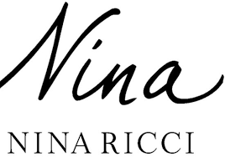 

 

**Training & Courses:**

* ICDL Course
* Electronic trade.
* Customer gust.
* Commutation skills

**Qualifications & Skills:**

**Language Skills:**

* Very Good English spoken and written
* Arabic mother tongue

**Computer Skills:**

* good user of Oracle system
* MIS system.
* CORE System.
* Very good user of MS Office 2003 & 2010
* Perfect Knowledge of using the Internet & its Applications
* Very Good typing speed {English: Very good - Arabic: Excellent}.

**Personal Skills:**

* Creative and self motivated
* Excellent communication skills
* Ability to work under pressure
* Problem solving skill.

**Interests**

* Product Knowledge for any Brand , Enjoy the Filed of selling, I love the retail and sales.

**Personal Data:**

**Date of Birth**: 29-novmber -1987.

**Nationality:** Egyptian.

**Marital status:** Married

**Military service:** **Postponed**.

*References furnished upon request.*