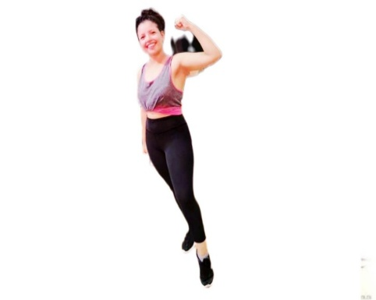***Contact***

***Ameni Merghmi : physical education teacher***

***Email :amenimerghmi2019@gmail.compphone number : 90243439***

***location : Kef Tunisia***

***Birthday : 03-01-2000***

***Education :***

***.2018_2019 : high school 2 Mares barnoussa***

* ***Bachelor’s degree sports***

***.2021_2022 : higher institute of physical and sports issep kef***

* ***Basic licence in physical education***

***.2021_2022 :higher institute of physical education and sports issep kef***

* ***Coach 2nd degree of body expression***

***.2021_2022 : NFG Academy evente***

* ***Coach fitness freestyle (step aéro fonctionnelle cardio)***

***2021_2022 : Coach 1nd judo.***

***Arbitre 1nd judo***

***2022 : master of physiology and biomechanics of exercise***

***Professional experience*** :

***2022 Coach fitness freestyle (step aéro fonctionnelle cardio) salle l’aréna***

***2021_2022 : Coach gymnastics and judo (salle lmoustakbel)***

***2019-2022 :coach wrestling ( association de barnoussa .FSKB)***

***Certificate*** :

***Certificate of participation in Aikido international course under supervision with kristina bit 2018***

***Certificate in first aid 2021***

***Certificate degree referee2021***

***Certificate of participation in Aikido international course under supervision with Alfred vaton 2017***

***International intermediate team Championship. 2017_2018***

***Senior regional championship 2018***

***National Wrestling championship certificate 2019***

***Skill :***

***Language***

***Arabic : excellent***

***English : good***

***French : excellent***

***Sports***