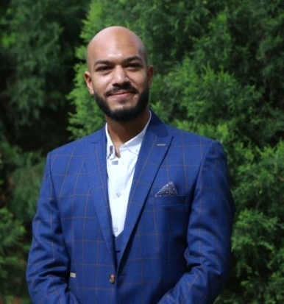

**Hossam EL-Din Ibrahim Zaghloul**

* **Personal Information:**

Business Name: Hossam Zaghloul

Address: 29 EL- Taawan St - king Fisal, Giza.

Religion: Muslim.

Nationality: Egyptian.

Marital Status: Single.

Mobil:01112707606.

Email:  [hossamwafd@gmail.com](mailto:%20hossamwafd@gmail.com)

Military stats: served in the military service.

* **CAREER OBJECTIVE:**

Seeking a challenging career with progressive and successful organization that provides an opportunity to capitalize my skills and to professionally pursue what I am talented at writing and photographing.

* **EDUCATION:**

Bachelor of Mass communication, major Journalism & Public Relations 2016 at Akhbar Al-Youm Academy.

* **Current Job:**
* Head of Wafd tags section, which care about SEO content.
* SEO content creator for Masr 2030 news site.
* **Experiences:**
* Member at Journalism syndicate form 2021.
* Monitor the content quality of Opera News Hub
* Wafd journalist form 2012

- Editor at news and current events section.

- Covered directory of Cairo's security.

- Judicial Editor.

- Video journalist.

- covered The Ministry of Electricity, The Ministry of Manpower and Ministry of Supply.

- Tracking Parliament news.

- Night shift responsible at news section.

* Disk editor at EL Horeyya Journal.
* Editor at EL Nedaa Journal.
* Preparation programmer at "YesedSabahk" program.
* Editor at Arab & Africa press news agency.
* Head of News section EL-Sabah EL-Araby website.
* Reporter at Erem news.
* Editor at Misr EL-Arabia website.
* Head of Political Section at EL-Khames Journal.
* Editor at the weekly Journal "EL-Rayah"
* Editor at AL-Nahar Journal.
* Editor at Alrai news
* Editor at News Gate
* **Courses:**
* Comprehensive course presented by the Egyptian Journalists Syndicate
* Journalism course at the Middle East News Agency.
* Course at Photography.
* Course at Investigative Journalism from O2.
* Course at Radio Broadcast.
* Course at Drafting Press under the super vision of the Journalist AmrEllissy.
* **SKILLS AND ABILITIES:**
* Languages:

Arabic – mother tongue

English – Excellent

* Technical skills:

Computer skills (Microsoft office – Word, Excel, PowerPoint, Internet)

Data analysis

Social media moderating.

* Other skills and abilities:

Excellent verbal and written communication skills.

Ability to work independently or as a part of team.

Proven leadership skills and ability to manage responsibilities.

Highly organized and efficient.

Adaptability.

Decision making.

Time management.

* **REFRENCES:**

Will be provided upon request.