|  |  |
| --- | --- |
| ***Nationality***  ***Date of birth***  ***Marital statues***  ***Phone number***  ***e-mail***  ***Address*** | : Egyptian  : February,21,1999  : Single  : 01121904599  : mouniraahmed299@gmail.com  : 31 shohdaa- elyman st. – Matarya- Cairo |

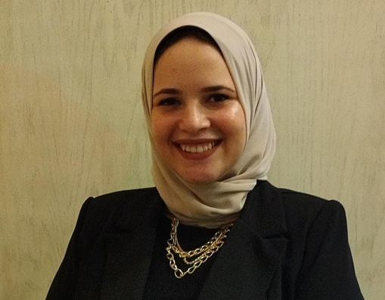

**Mounira Ahmed Bahaa Eldin** **Mostafa**

**Career Objective:**

**Seeking a suitable position that utilizes my accounting , computer, language**

**skills, fulfills my personal ambition and enhances my knowledge.**

**Educational Background:**

* 2019 Technical Commercial Institute, Matareya

commercial technical institute

* 2022 Faculty of Commerce, Ain-Shams University, Major(Accounting)
* General Secondary certificate 2017.

**Working experiences:**

* H.R assistant at smart eygpt for security ( from 03-2021 to 06-2021 )
* Pharmacist Assistant ( from 01-2018 to 03-2021 )

**Practical Experience:**

**Daily duties, Responsibilities**

* Accurate data entry & keeping of records.
* Photocopying, scanning and printing documents.
* Capable of handling all kinds of secretarial works.
* Sorting and distributing incoming communication data; including letters & emails.
* Making salaries & attendance reports for employees (excel).

**Skills:**

**Computer Skills:**

* good user of Windows, Word, PowerPoint, Excel
* Good surfing skills on the Internet.

**Language Skills:**

* English: Good level

**Other skills :**

* Active
* Good observer
* Ambitious
* Communication skills
* Challenger
* Good time management
* Willing to learn
* Ability to work under pressure
* Working both individually or in a team
* Can adapt to any work environment
* Problem solving

**Interests**

* Surfing on the Internet.

Any further references will be available upon request.