**CV**

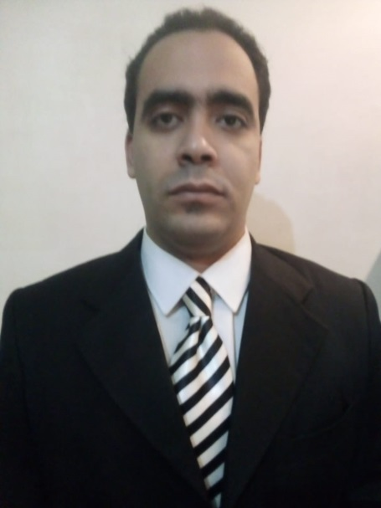

Name: Basel Hassan Mohamed Abdelghafar

Email: [baselhassan2010@gmail.com](mailto:baselhassan2010@gmail.com)

Mobile No: 01152100570

Address: Building No.40 Alta'aneat, Elsherouk City, Cairo Egypt

Date of Birth: 5-8-1997

Age: 25

Nationality: Egyptian

Martial Status: Single

**Qualification and courses:**

Fourth year student, Faculty of Arts, Helwan University

ICDL

TOEFL

Work under pressure

Able to work in a team (Extrovert)

**Current and previous practical experience in the field of work and the number of years:**

Worked as a researcher in the Central Agency for Public Mobilization and Statistics for 6 years

**Languages:**

Fluent in English