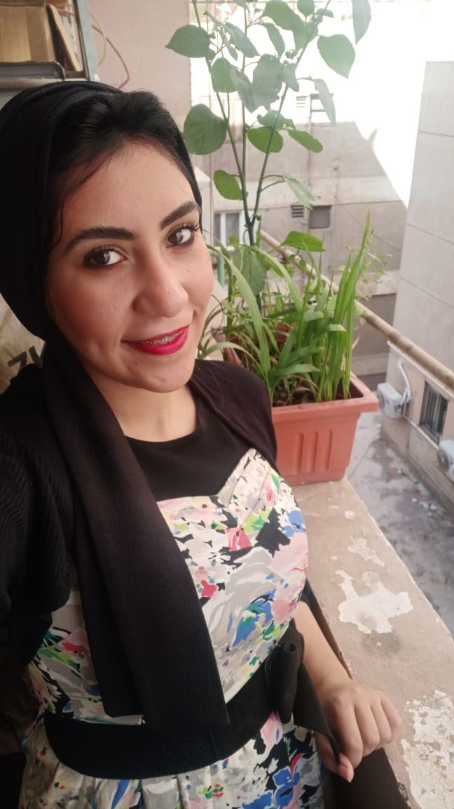

***Personal Details***

* ***Date of Birth:* 27-4-1993**
* ***Nationality:* Egyptian**
* ***Religion :* Muslim**
* ***Social status:* single**
* ***Address*: 2 Abo mousa Elashary**

**Nasr city**

* **Mobile: - 01010271267**
* **Gmail : *Yasminrizk1993@Gmail.com***

***Languages***

* ***Arabic* – Native**
* ***English* - (Writing, Understanding, Speaking) – Good**

**Professional Backgrounds**

***Position: - HR Specialist***

***From: - 6/2021 till Now….***

**Responsibilities**

* Preparing and reviewing compensation and benefits packages.
* Administering health and life insurance programs .
* Implementing training and development plans.
* Inform employees about additional benefits they are eligible for (e.g extra vacation days).
* Update employee records with new hire information and/or changes in employment status.
* Maintain organizational charts and detailed job descriptions along with salary records.
* Forecast hiring needs and ensure recruitment process runs smoothly.
* Develop and implement HR policies throughout the organization.
* Monitor budgets by department.
* Process employees’ queries and respond in a timely manner.
* Work employee handbook.
* Treasury check work.
* Disbursement and settlement of employees' custody.
* Reviewing inventory documents (Additions and existence).

***⮊ Yummys***

***Position: - Barista***

***Part time***

**Responsibilities**

* Greeting customers as they enter.
* Providing customers with drink menus and answering their questions regarding ingredients.
* Taking orders while paying attention to details (e.g. preferences of coffee blend, dairy and sugar ratios).
* Receive and process payments (cash and credit cards).
* Maintain stock of clean mugs and plates.
* Check if brewing equipment operates properly and report any maintenance needs.
* Comply with health and safety regulations.
* Communicate customer feedback to managers and recommend new menu items.

***⮊ JWFrame Network***

***Position: - Accountant***

***From: - 2/2019 till 5/2021***

**Responsibilities**

* Tracking payments to internal and external stakeholders.
* Manage all accounting transactions.
* Publish financial statements in time.
* Reconcile accounts payable and receivable.
* Ensure timely bank payments.

***⮊ M Dent Clinic***

***Position: - clinic manager***

***From: - 9l2015 till 2/2019***

**responsibilities**

* Monitoring budget and billing payments.
* Ordering medical and office supplies.
* Develop and implement office policies and procedures.
* Maintain patients’ records.
* Generate inventory records.
* Scheduling appointments.
* Ensuring the reception area is clean and welcoming.
* Balancing patient accounts and taking payments for services rendered.
* Reviewing bills and claims for accurate information.
* Entering data into the Clinic database.
* Preparing billing reports and other documents.
* Balancing patient accounts and taking payments for services rendered.

***⮊ Etisal International -Al Tazaj | الطازج***

***Position: Call center***

***From : - 2l2015 Till 8/2015***

**responsibilities**

* Follow communication “scripts” when handling different topics.
* Identify customers’ needs, clarify information, research every issue and provide solutions and/or alternatives.
* Selling and giving information on the products or services.
* Following up on customer calls.
* Managing and updating customer databases.
* Handling customer complaints.

***⮊ Egyptian Dental Center***

***Position: - receptionist***

***From: -2/2012 12-2014.***

**responsibilities**

* Answering screening and forwarding incoming phone calls.
* Greet and welcome guests as soon as they arrive at the office.
* Order front office supplies and keep inventory of stock.
* Update calendars and schedule meetings.
* Book patients in for appointments.
* Enter patients’ details onto IT systems.
* Direct patients where to go within the department.
* Book appointments by phone.
* answer queries from patients and other staff health Centre.

**Education**

* ***Faculty of Art***
* ***Ain-Shams ِ Uni - Year: - 2015.***

**Training Courses**

* ***English Courses***
* ***ورشه اعداد و تطوير المديرين***
* ***PHRI Workshop***

**Skills**

* **Basic math skills**
* **communication skills**
* **Flexibility to work various shifts**
* **Ability to gauge customers’ preferences**
* **Complete know-how of MS office suite**
* **Certified human resources specialist with a certificate from an HR certification institute**
* **Good organizational skills**
* **Skills to multitask efficiently and the ability to work in a fast-paced work environment**
* **Positive attitude towards challenges and excellent problem-solving skills**
* **Sound knowledge of human resources management software**
* **Know-how of employee payrolling system**
* **Ability to securely handle employee records**
* **Strong attention to detail and good analytical skills**
* **Professional attitude and appearance**