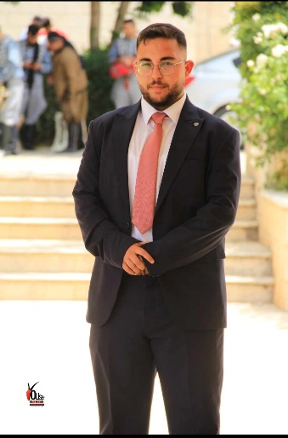

Qutadah.Shanaa

EMAIL: [qutadah2000@gmail.com](mailto:qutadah2000@gmail.com)

Phone: +970592973890

Palestine - Tulkarm

|  |  |
| --- | --- |
| **Career Objective** | Always doing my best to improve my skills & willing to |
| solve any problem by the appropriate technique |
|  |
|  |



* Free business:- from 1\2022 untill now

|  |  |  |
| --- | --- | --- |
|  |  |  |
|  | **“Electrical technical”** |  |

* One phase and three phase house and industrial

electrical extensions.

* Presenting quotations to customers and institutions and supplying them.
* Design and implement factory control circuits and work to develop and amend them.
* Work on power and lighting distribution systems for homes on one and three systems.
* Establishing and arranging control lines for PLC systems and automatic gates.

**THE CELLS- company**

**“Trained Engineer”**

Manufacturing a small production line as a graduation project, PLC Controller and an HMI screen.

|  |  |
| --- | --- |
| **●Bachelor's degree** | 2018 - 2023 |
| Electrical Engineering |  |
| Palestine Technical University – Khadoore.  **Languages** **●** Arabic (Native Speaker)   * English (Good) reading, writing and conversation        |  |  |  | | --- | --- | --- | | **Skills** | **●** Learning | **●** Management | |  | **●** PLC , HMI | **●** Solve problem | |  | **●** Computer | **●** Speak | |  |  |  |  |  |  |  | | --- | --- | --- | | **Identifiers** | **●**Dr.Mahmoud Salah | +970599566319 | |  | **●** Dr.Samer Sadi | +970599410707 | |  | **●** Eng.Nabeel Altaneh | +972593030143 | |  |