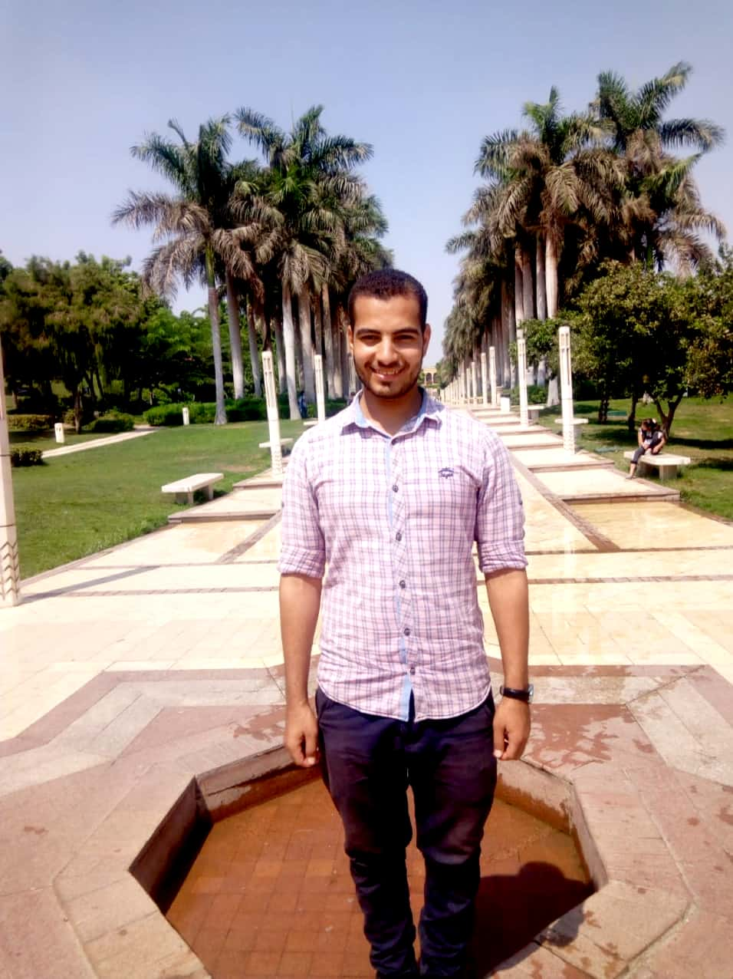 |  | hussein nasser
Profile  My name is Hussein Nasser Hussein. I am 27 years old. I live in Mansouriya, Manshaat Al-Qanater Center, Giza.  I graduated from the Faculty of Arts, Cairo University, with a good grade in 2017, I worked as a storekeeper and on corporate management systems. I try to develop my abilities by learning from others or through online courses.  I am learning more and more to set up a project of my own that benefits people.  Contact  PHONE:  0150167809  EMAIL  Sonaa4025@gmail.com  activities and interests  writing and blogging  Social work  reading  Volunteering in the government sector |  | WORK EXPERIENCE  Store keeper  Noon for marketing, Abu-Rawash Industrial Area .  2019 : 2020  Receiving the products, reviewing them with the quantities and expiry date, placing them in the designated places, and then dispensing them upon request.  - I scan the barcode on the item and register it on the system, then the item lives in the place that I specify, and when requested by any customer, this item is prepared, then the storekeeper at the exit stage takes the item, prepares it, and delivers it to the shipping company  Store keeper  ATG for trade and supplies, Abu-Rawash Industrial Area  2022 : yet  Receiving the products, reviewing them with the quantities and expiry date, placing them in the designated places, and then dispensing them upon request.  - I enter the invoices received from the suppliers on the MC Oracle system, make the permissions for the branches on the system, print and prepare them, and after handing them over to the representative, I deduct the items from the system.  EDUCATION  College of Literature  2017  Bachelor of Arts, Department of Arabic Language and Literature.  key skills and characteristics  Problem Solving  Critical Thinking  Communication Skills  Teamwork  Organization  Creativity  Attention to Detail

