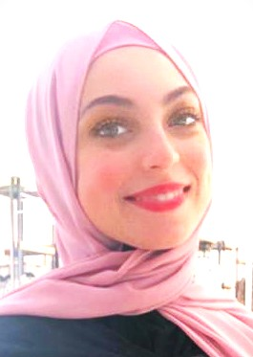

Mai Ahmed Abdel Hafez

**About me**

**EDUCATION**

**Faculty of Art**

**Tanta University**

**Specialization: English Language Literature**

**Graduation Year: 2016 - 2017**

**Seeking a position at your company and I promise to do my best to achieve what you want from me well.**

**CONTACT**

**mai.elborgi@gmail.com**

**Work experiences**

**🖂**

✆

**A Secretary in a hospital in Kuwait (2016 – 2018)**

**A call center in a newspaper in Shahd in Kuwait (2015 – 2016)**

**A secretary in a construction company in Kuwait (2019)**

**A receptionist in Dentinal clinic in Kuwait (2019)**

**01001168746**

**🏠**

**54 Mathaf Almatrya - Elnaam – Ain Shams, Cairo. Egypt.**

**– Cairo- Egypt**

**The language**

**- I speak English well in terms of reading, writing and listening**

**- I speak Arabic well.**

**Professional skills**

**HOBBIES**

**- Good Communication skills**

**- Working under Pressure**

**- Able To learn new tasks quickly**

**- Fulfilling instructions perfectly and completely.**

**Reading**

**🖉🖉**

**Computer skills**

**🛪**

**Travel**

* **Office (word – excel – power point )**
* **Excellent at using the internet websites**

**Personal Information**

**- Date of Birth: 08/06/1994**

**-Marital status: Married**

**- Religion: Muslim**