**Ahmed BENFERHAT**

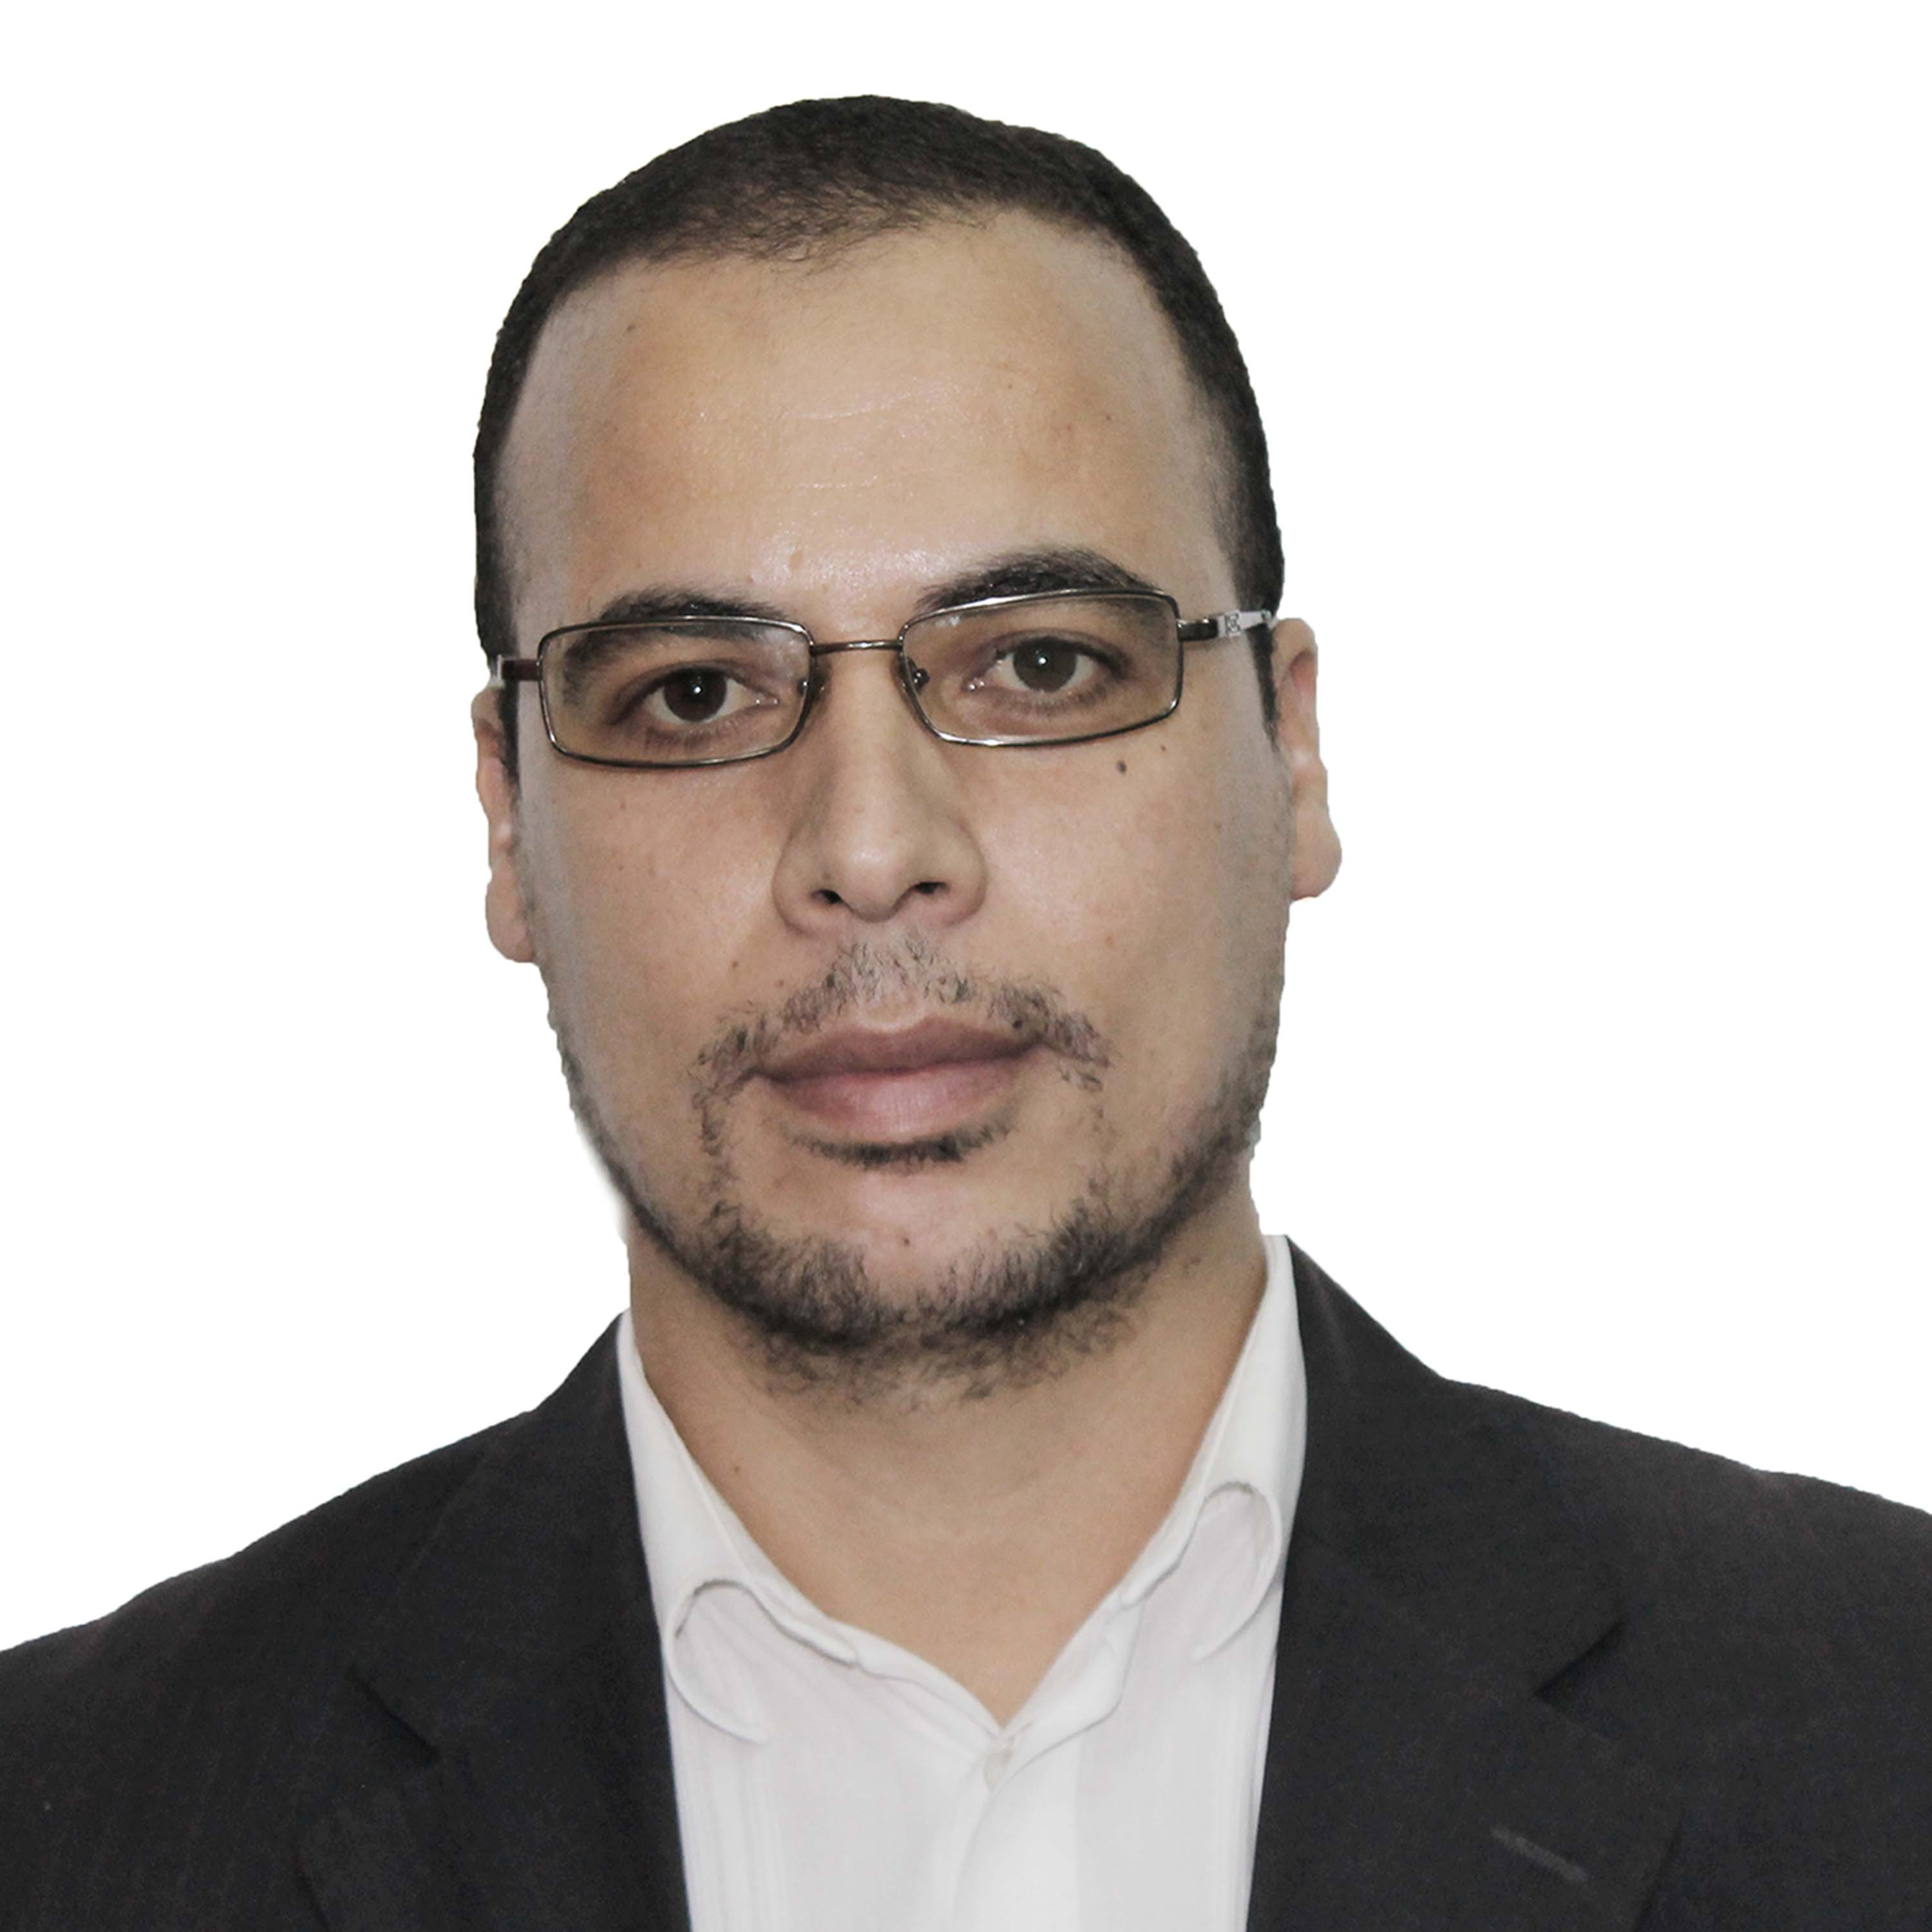

**PhD student in political sciences**

**Field of research: Energy transition policy**

# **Personal data:**

Name : **BENFERHAT Ahmed**

Date Place of birth: **20/12/1982 Koléa** , Tipaza , Algeria .

Adress :city 1350 AADL.Bt37 Bousmail Tipaza.

Marital status : Married, three children

Professional email :[a.benferhat@univ-chlef.dz](mailto:a.benferhat@univ-chlef.dz)

Phone Number: +213552573667

## **Academic Qualifications :**

* **2022-2023** : 5th year registration ; PhD student in political Sciences from Chlef University , Algeria since October 2018 , thesis titled “The institutionalization of energy transition in the Maghreb countries. Comparative study: Algeria, Morocco
* **October 2018** :Ranked first in passing the Doctoral contest,.
* **Sept 2017** :Master Degree in international crisis Management from the National High school of political sciences, Titled of research “The energy geopolitics in Middle east’’ .
* **Jun 2010:**Bachelor's degree in legal and administrative sciences from the Blida University, Algeria.
* **Jun 2015** :Bachelor's degree in Italian Language; from the Blida University, Algeria .
* **Jun 2004 :BTS** degree (higher technician's certificate.) in Statistic from INPS ; Algeria ;2004.
* Baccalaureate in Nature Sciences, sessions :2000;2005;2006

**Professional Experience:**

* Administrator at High School of Business Studies, EHEC Kolea, Algeria, since February 2015 .
* TS statistic in court . Ministry of Justice ; Algeria Ap 2009- Feb 2015.
* Part Time Teacher at at High School of Business Studies EHEC, Algeria
* , 2017-2018 : Teaching "Italian Busniss".
* Member of the Graduatel Research Laboratory : society and local development problems in Algeria, since October 2018.

**Training:**

* Short-term training in the EHEC , Field “ The quality Assurance at the EHEC, 2008.
* Short - term Training in the APC Douaouda, field “Management of Human resources; Algeria,2004.

# Short - term professional Training in Jordanie And Morooco in 2017.2018.

# **Academic Activities**

* Participation in research paper entitled “the challenge of energy security in Mediterranean ", national seminar; university of Chlef, Algeria, On Juan 2019.
* Participation in research paper entitled “the Mediterranean dimension of the European Union's energy policy, On October 2019.
* Participation in summer holidays workshop, infibulated :How to write an article ?: university Coventry UK with university of Jijel. On September 2019.
* Participation in research paper entitled “The Algerian Transition Energy policy in the context of economic renewal“, On Decembre 2020.
* Participation in organization of many national seminars and studies days.
* Publication an article entitled “institutionalization of energy transition in Algeria”, found on ASJP, August 2021.

# **Skills:**

**Language skills** : Arabic : Excellent/ Italian Medium/ English : : Excellent French : Good.

**Computer skills:** Ms office , SPSS.