Osama Gamal
Suitable career & position for my qualifications and my abilities
in progressive company that will support me to utilize it effectively,
creatively and to be promoted as well as building on my previous experience.
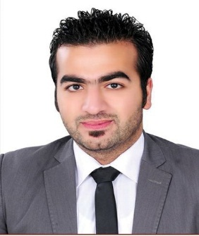
15 Sefrat Square
nasr city in cairo
01157399191-01111451144
01111889934-0220467607
osamageme7@gmail.com

EXPERIENCE
Amer group
Senior sales
I have 5 years experience in real estate sales in New Cairo, the new capital and most parts of the Republic
I love working under pressure and always strive to achieve the best sales through some important elements, including my own data, through my sponsored ads, through relationships, real estate marketing skills, and the method of selling to increase sales
Tabarak Holding
Sales consultant

June2019-october2020
Meet personal and team sales targets.
Strong persistence in dealing with people and not giving up easily.

Cleopatra Group
Sales consultant

May 2018  may 2019
Meet personal and team sales targets.
Strong persistence in dealing with people and not giving up easily.

ERA Real Estate Com pany, CAIRO 4​th Settlement —​

Sales, Marketing
Dec 2017– Apr2018
Meet personal and team sales targets.
Strong persistence in dealing with people and not giving up easily.

Elite Real Estate Company, 5​th Settlement- Property advisor
Nov2016 – Nov2017
Meet personal and team sales targets.
Strong persistence in dealing with people and not giving up easily.

Antrex service int. Shipping, Sherton — ​ Sales, act as Call​ center
Feb 2014 - Jan 2015
Meet personal and team sales targets.
Strong persistence in dealing with people and not giving up easily.

I worked as a driver at Uber for 2 years.

Personal Information
Date of birth: 28-​July-1992
Gender: Male​
Marital status: Single​
Military service: Exemption​ Nationality: Egyptian​

SKILLS
Microsoft Office.
Microsoft Outlook. Have a good ability for understanding & learning.
Teamwork spirit.
Good interpersonal relation skills.

LANGUAGES
Arabic: Mother tongue​
English: professional working​ proficiency

EDUCATION
Modern Academy, Cairo, Egypt — ​ Bachelor of Economics​sep 2009 - June 2013
Project degree: Very good
COURSES
Future Academy, Cairo, Egypt — ​English​
Jane 2015 - Dec 2015

Antrex Global system, Cairo, Egypt — ​ Logistics​
Jane 2015 - Dec 2015

School Laviva Cairo, Egypt — ​Softskills​
Jane 2015 - Dec 2015

