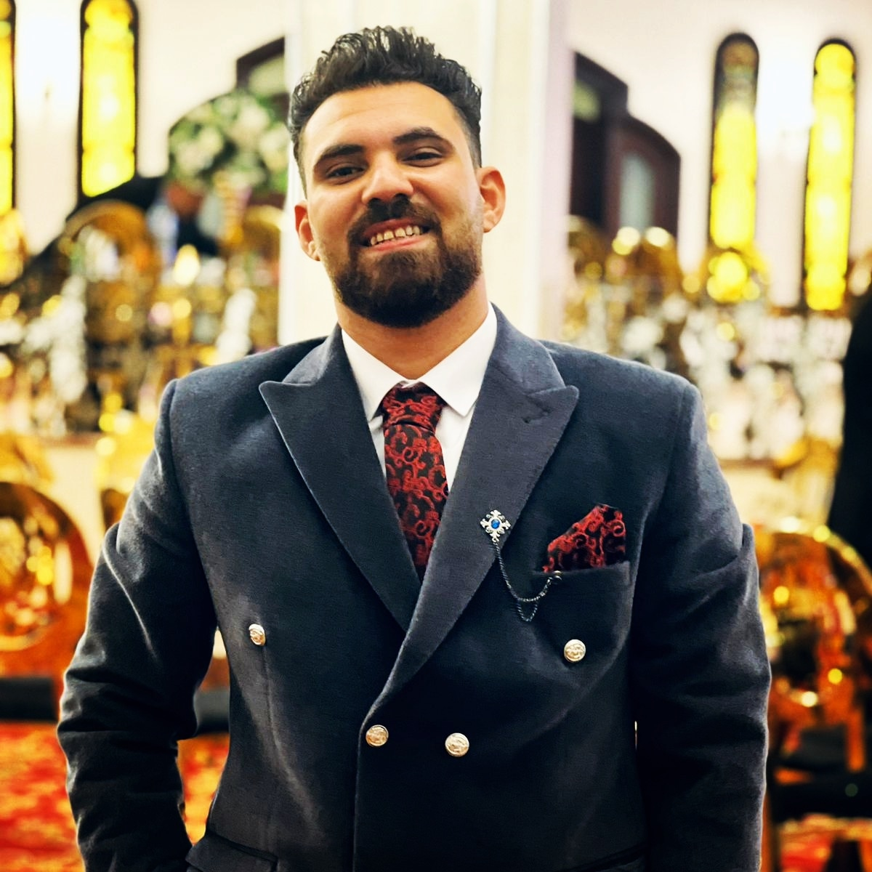

MOHAMED GAMAL MONER

El-Mokattam Glden Gates . building 71 ,Cairo, Egypt

Gmail:jmal23906@gmail.com

(+02) 01110930844 & 01122335682

Summary
Seeking a challenging and responsible position in " management information system " Which my knowledge & Skills are applied to expand my experience in this field for more development of my own performance.

Personal Data

- Data of Birth: 7 /08/1997

- Place of birth: El-Mokattam area , Cairo, Egypt

- Nationality: Egyptian

- Gender : male

- Marital status: single

- Graduate of the cairo higher institute

- Qualified study: management information system

- Graduation Year: 2019

Education

- 2015-2019 collage: cairo higher institute for systems and information
- 2012-2015 Secondary School : industrial school electrical
- 2010-2012 preparatory school: Shaimaa Preparatory Boys
- 2004-2010 primary school : Omar Bin Abdulaziz

Experience
- I worked at brand moko for casual wear from ganuary (2015) to October (2016)

- I worked at uptown cairo as acamera operator from april (2017) until may (2018)

- I worked at delta insurance company as a sales employe from may (2018) until septemer (2019)

- I worked as a sales employe in a shoe company from august (2019) until may (2020)

- I worked at zahir dairy company a data and empoye of receipts for branches and stores from march (2021) until april (2022)

- I worked at top Egypt water treatment company as a collection employe and respond to complaints from September (2022) until November (2022)

- I worked at hubei import and export company secretary and data entry employe from January (2023) until February (2023)

Courses
- Field traning course at cairo hidher instate of administrative information and systems

Bersonal skills
- Cooperation and prarticipation in the work with the group
- Helping others and extending the spirit of cooperation to others

Languages skills

- English ( very good )

Computer skills

- Microsoft Office.
- internet user
- Good computer maintenance skills
- Able to deal with any new kind of programs or technology

