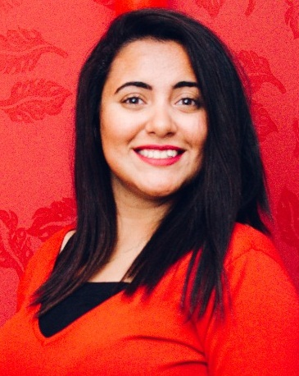**Neveen Boshra Baskharon**

**Date of Birth: 01st Jan 1997**

**Address: 15may, Helwan.**

**Marital Status: Single**

**Gender: Female**

**Nationality: Egyptian**

**Phone No. : 01203335214**

**Email:** **neveenboshra333@gmail.com**

***Qualification***

**Bachelor of Commerce from** **[Thebes Academy](http://www.thebesacademy.org/)**

**Department of Accounting**

***Related Skills***

* ***Languages***

***. Arabic :*** Mother tongue.

***. English:*** *Good*

***Personal Skills***

* Excellent communication& interpersonal skills
* Handle all income correspondence and maintain follow up system
* Handle routine office administration
* Willingly to work & effectively
* Social , organized & cooperative
* Confident & strong personality able to work under stress condition
* Stand in front of the public.

***Computer Experience***

* Operating Systems (WindowsXp, Win vista, Win 7, Win 8).
* Dealing with internet application excellent.
* Word.
* Power point.
* Excel.

***Work Experience***

* Public Relations Officer for Wadi Degla Sports Club

From March 2015 until Now

***Training and Special Courses***

* ******English speak out & English conversation Course with **Instructive British Institute**
* Computer Course with **Instructive British Institute**
* ICDL Course with **Instructive British Institute**
* TOT Course (training of trainer)

**CopticEvangelical Organization for Social Services**

* Human development courses (communication skills _ team work _ self confidence_ strategic leadership_ Personal patterns _ Thinking patterns _ customer se).

**Coptic Evangelical Organization for Social Services**

#### Hope my qualification meet your expectation and I will very much appreciate if you accept my application and ready for providing all required documents

# Note:

**For any further information pls; don't hesitate to contact me at above Tel or address.**

**With all my respect, nevin boshra**