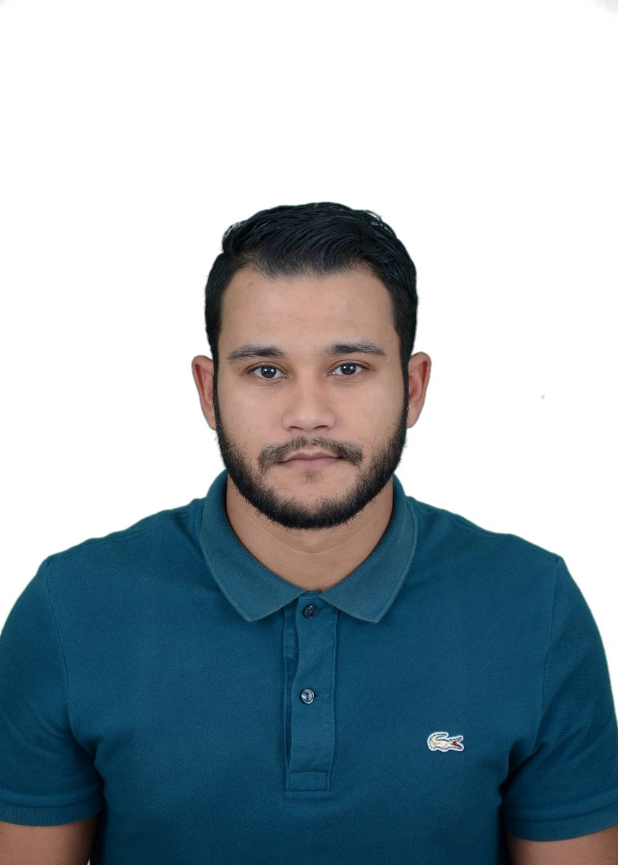

SUPERVISOR

PERSONAL DETAILS

Name MOSBAH
First Name NADIR
Dates and place of birth 25/04/1995 at Skikda Algeria
Family status; Single
Address: Cite 180 LGTS LPP Bt 09 N04 Skikda 21000 Algeria
Phone (mobile): (+213) 558847294
Email : msbhkhaled21@gmail.com
Car driving license: National.

EDUCATION

2022 > International Trade Senior technician, International Institute of Management
INSIM-Constantine –ALGERIA-
IT SKILLS

- Word, Excel, Power point, Outlook Express, Internet & E-mail applications,
LANGUAGES

- Arabic : Native
- French: Fluent
- English : Intermediate

WORK EXPERIENCE

  - From October 2021 onward

Position: Supervisor.
Company: BAYAT Catering- ALGERIA.

Duties and responsibilities:

The main duties are:

- To receive the supply request from the construction sites.
- Controlling and monitoring the construction sites.

Key Responsibilities:

- Create and implement best practices, vision, strategy, policies, processes and procedures to aid and improve business performance
- Providing technical support to the construction site.
- Coordinate with every interface to ensure the deadline work.
- Resilient, optimistic and open to change.
- Self-motivated and able to work well under pressure.

