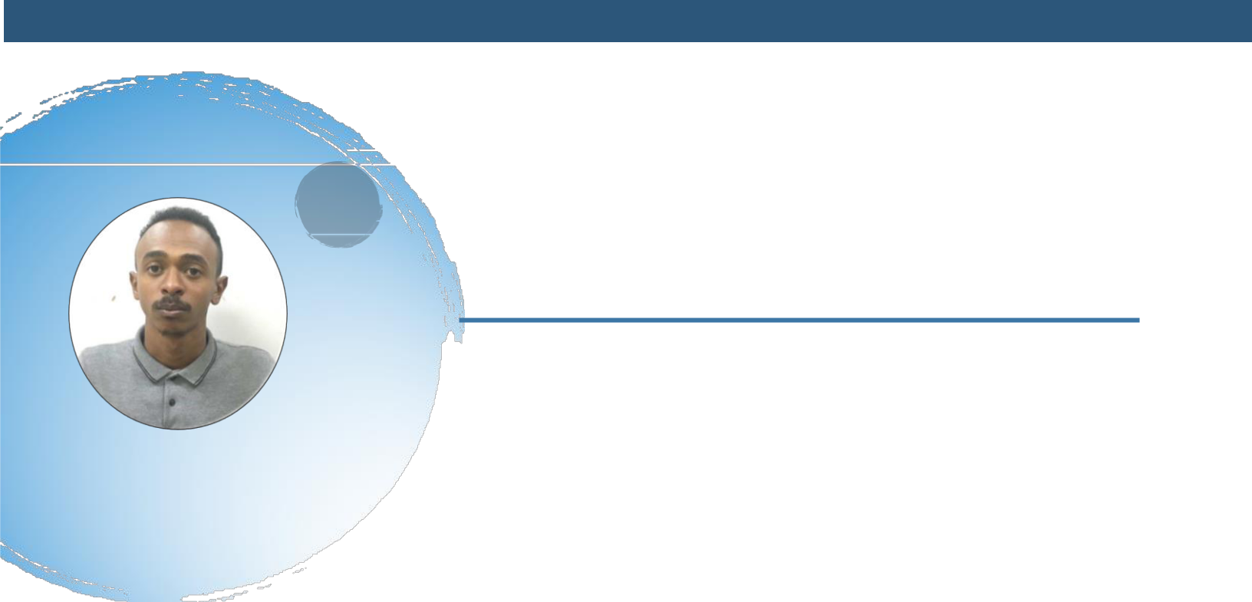
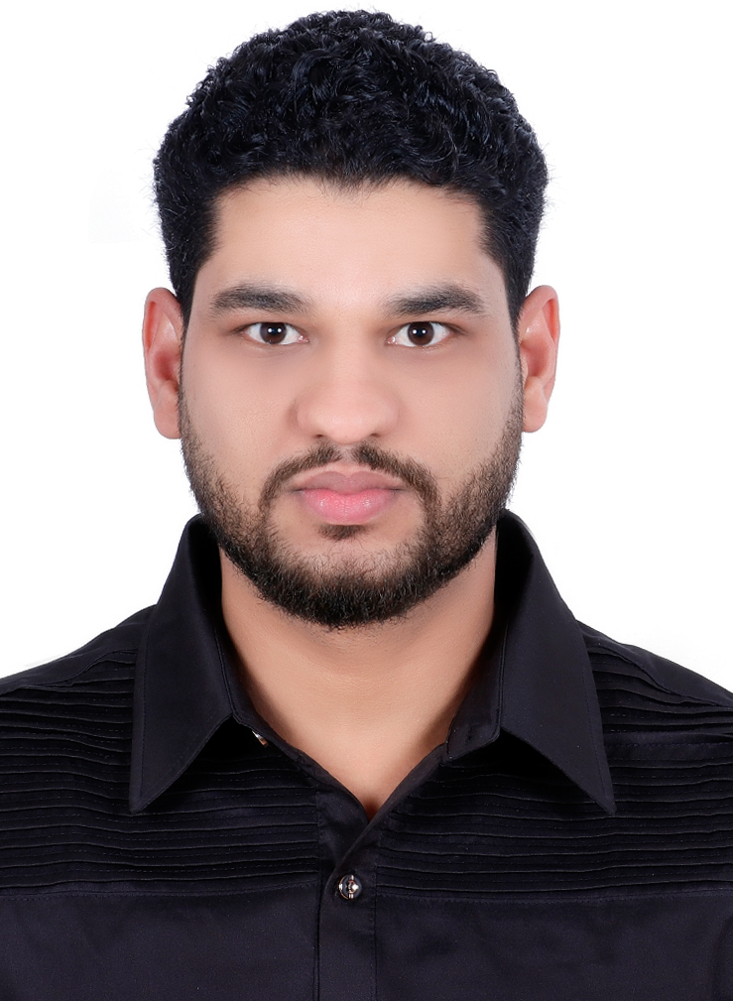



Sharjah - United Arab Emirates



00249918208483



0583029855



yasinelfatehm@gmail.com


Single


30/04/1996


Sudanese

YASIN ELFATEH ALSIED

Medical Laboratory Second Specialist

Objective

Medical laboratory second specialist with a qualified degree in medical laboratory sciences and more than two years’ experience in the field, I have Dubai Health Association (DHA) license and I can operate and deal with most advanced laboratory analyzers mainly hematology & chemistry analyzers, looking for a job outside Sudan to expand my experience in a busy and professional environment.

Availability: Upon request.

Education

2013-2020: University of Science & Technology- Sudan -

Medical laboratory science Module studied: Hematology, clinical chemistry, histopathology, Microbiology, Parasitology.

2020-2021: Completion of the Qualifying - Institute of Endemic Diseases the University of Khartoum - Sudan Modules studied: Immunology, Molecular Biology, General Pathology, Parasitology, and Epidemiology.

Experience

2021 – 2022: Accuracy Laboratories – Sudan as laboratory second specialist in laboratory department.

2020 –2021: Omdurman Friendship HOSPITAL – Sudan as laboratory second specialist in laboratory department.

Publication
Prevalence of intestinal parasites among food handlers attending public health laboratories in Khartoum State Sudan as Co Auther

Languages
Arabic: ⬄⬄⬄⬄⬄
English: ⬄⬄⬄⬄ 


Personal skills
Communication: ⬄⬄⬄⬄⬄

Leadership: ⬄⬄⬄⬄ 

Time Management: ⬄⬄⬄⬄⬄


Technical skills

Work with Most Advanced ^{⬄⬄⬄⬄  computerized laboratory}
Equipment:

I can operate and deal with the following full automated laboratory analyzers in addition to the manual and semi-automated analyzers:

- Automated hematological cell counters (SYSMEX KX – 21N & XP 300 hematology analyzer).

- Automated coagulation analyzers (STAGO)

- COBAS INTEGRA 400 PLUS chemistry Analyzer.

- Cobas C 311 chemistry Analyzer.

- Cobas 411 immune analyzer.

- Mindray BS 200 chemistry Analyzer.

- Blood gases and electrolytes analyzers.

Microsoft Office:

Internet and E-mail:

Typing Arabic/ English:

Training and Courses:
⬄⬄⬄⬄⬄ 

⬄⬄⬄⬄⬄ 

⬄⬄⬄⬄ 

- Medical Laboratory Certified Quality Manager – London Academy for Training & Education.

References

- Dr.: Tarig Abderahman Gamar – Medical Laboratories Consultant and Ass. Prof. Ministry of the health Khartoum state Omdurman AL Fatih Hospital – Khartoum– Sudan - Tel: 00249912902242 - Email: tariqquamer35@yahoo.com

- Dr.:Elbashir Abdelmalike Mohammed –Senior Histotechnologist-Fakeeh University Hospital –U.A.E - Tel:0551572707 – E-mail: barribasheer@gmail.com



