Curriculum Vitae
It is an honor for me to introduce this C.V. with my personal information to apply to work in your group as an employee contributing in the development of this corporation.

Personal Information

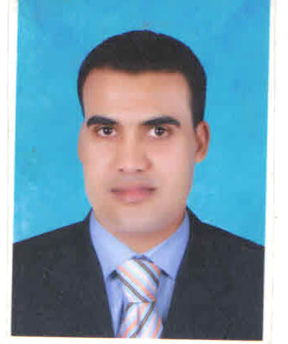
Name : Gasser Mohamed Abdel khalek Mustafa
Date of Birth : 27/11/1979
Place of Birth : Qus
Gender : Male
Marital Status : Married
Religion : Muslim
Military Status : Exempted
Nationality : Egyptian

Contact Details

Address : Egypt - Qena - Qus - Nagragab
Tel : 0962200297
Mob : 01011212855 - 01228590240
Email : Gassersarhan@yahoo.com – Gassersarhan@gmail.com

Objective

I am self-motivated, ambitious and eager to learn. I am a responsible individual with strong communication skills and work ethics besides being creative, focused and highly determined. I am willing to take responsibility and work independently. At the same time, I can work well in teams.

Education

Bachelor of Social Service From Higher Institute of Social Service (for the year 2000). Diploma in Education From South Valley University (for the year 2003).
Diploma of Tourism From Higher Institute for Tourism and hotel (2012).

Languages

English : Very Good (Speaking-Reading-Writing)
Arabic : Mother Tongue
Italian : Very Good (Speaking-Reading-Writing)

Computer Skills

Windows (All Versions)

Microsoft Office (Word, Excel, Outlook and PowerPoint).
Good user of Internet and outlook Exchange programs.
Fidelio hotel management and operation system .
Comsys hotel management and operation system.
Promaster hotel management and operation system .
Protal hotel management and operation system .

Personal skills

Ability to work under pressure.
Flexible & team worker, ability to relate to people at all levels.
Can adjust promptly in any new environment.
Positive attitude.
Experience in handling different types of guests including VIPs.
Develop & maintain high level of communication.
Excellent level of customer service.
Up-selling skills.
Excellent presentation skills.
Promotional & Marketing skills.
Training skills.
Good conversation skills.

Work Experience

Job title: Assistant Front Office Manager
Organization: Emerald lagoon view 4*Marsa alam (Future lagoon view group)
From: 07 March 2017 up to 01.02.2019

Job title: Assistant Front Office Manager
Organization: Nada Resort 4* Marsa alam (Nada group tourism)
From: 01 July 2015 until 02 October 2016

Job title: Front Desk Senior Supervisor
Organization: Gamma Resort 4* Marsa alam (Allayed group tourism)
From: 05 August 2012 until 01Jun 2015

job title: Front Desk Supervisor
Organization: Abu Nawas Resort 4* Marsa Alam (Bernice group tourism)
From: 05October 2011 until 20July 2012

Job title: Desk manager
Organization: Ms. Nile diva &spa 5*Luxor (Flash international hotel & cruises)
From: 13 September 2009 until 19 July 2011

Job title: Front desk shift leader
Organization: Blue Lagoon 4* Marsa alam (Best Egypt hotel)
From 05 august 2009 until 12 September 2009

Job title: Senior reception
Organization: Ms. Coral tow 5* (Delta Isis cruises & Hotels)
From 04 august 2008 until 01 august 2009

Job title: Front desk receptionist (G.S.A)
Organization: Tulip resort 5* Marsa alam (Flash international hotel & cruises)
From 18 December 2006 until 02 august 2009

job title: Receptionist
Organization : Ms. Lady Sophia 5* Luxor (Flash international hotel & cruises)
From 14 April 2004 until 27 November 2006

Training & Other courses

Grooming and Personal Hygiene
Good treatment of the guest (Be My Guest)
Telephone Skills Training

First Aid Role
Fire-Fighting Role
Front office Skill development
Certified Hospitality Department Trainer –CHD
Certified ICDL (Computer driving license)

Hobbies

Reading
Learning languages. Computer and internet

Sports

. Swimming. Running

Finally

I would like to be one of your successful team

Thank you
Best regards

