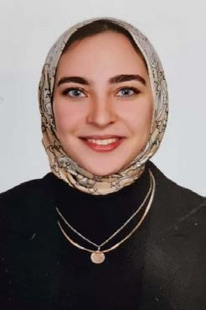**BASSANT MOHAMED HAMMAD**

Address: 80 EL-ESKNDRANI ST. MOHRM BEK. ALEXANDRIA

Email: bassantmohammed41@gmail.com

Mobile: 01279136837

Date of Birth: 22/7/1999

# Objective

I am multi-tasking person aiming for quality and quantity as well excellence service on everything I do. Able to prioritize effectively to accomplish objectives with creativity, enthusiasm and humor. Looking for a suitable position to take my career growth further along with the development of the organization, utilizing the abilities I’ve gained through my education, qualification and experience.

# Education

► Egyptian E-Learning University “EELU”

* Department: Business administration department ( finance)
* Date of graduate: 2023 ● Grade: very Good

# Training

* successfully completed the summer program themed “entrepreneurship” at Commercial international bank. “August 2022”
* Introduction to capital markets at “corporate finance institute”.

# Courses

* Microsoft office specialist (Word , Excel & powerpoint )
* Conversational English

# Language

* Arabic
* English (Very good in writing and speaking).

# Skills

* Hard worker and ambitious quick learner.
* Attention to details
* Impeccable organizational skills.
* Willing to learn continuously.
* Troubleshooting and research
* Speed and efficiency

**Experience**

* Consultant at CHUBB from ( June 2024 till now)
* Secretariat at Uc MAS from (6 February: 30 Abril ) 2024