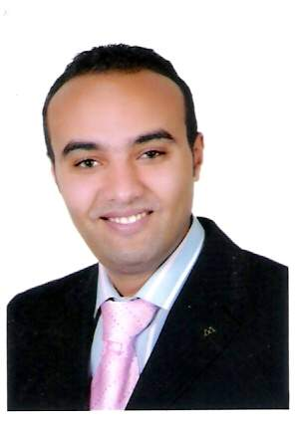Address: ***24-ELnozha st., Nasr city, Cairo, Egypt*.**

Home: **+202-24140865**

Mobile : **+2-0111-5649966**

E-mail: [**m_y_alsaud@hotmail.com**](mailto:m_y_alsaud@hotmail.com)

**Mohammad Youssef Abu EL-Seoud**

**Career Objective:**

* Seeking for Career Opportunity to work in a Challenging Environment where I make a Valuable Contributions to our company & develop myself in the Field of Pharmaceutical Sales & Marketing.

**Personal data:**

**\* Military service:** Exempted.

* **Date of Birth:** 20/10/1985.

* **Nationality:** Egyptian.

* **Marital Status:** single.

**Driving license:** valid. *

**Education:**

* **Bachelor Degree of Pharmacy** – October 6th University – 2007 with grade (Good).

**\* MBA candidate at Arab Academy for science , Technology & Maritime Transport ( Under Graduate ).**

**Job experience:**

* **Senior Second Line Sales Manager in Luye Pharma from July 2022 Till present.**
* **Regional Sales Manager in SoValue Pharma from Jan-2019 Till June 2022.**
* **Regional Sales Manager in AstraZeneca Responsible for Greater Cairo & Upper Egypt Team from Jan-2018 Till Dec-2018.**
* **Regional Sales Manager in Rameda Responsible for Greater Cairo & Upper Egypt Team from Jan-2017 Till Dec-2017.**
* **First Line Sales Manager in AstraZeneca CNS Line Responsible for Greater Cairo Team from Jan-2016 Till Dec-2016.**
* **Executive CNS Product Specialist in** **AstraZeneca** ,**CNS Line from** **Jan-2013 Till Dec-2015.**

* **CNS Product Specialist** **in Egypt OTSUKA** , **CNS** **Line** **from Oct-2010 Till Dec-2012.**

* **Medical Representative** **in** **Al-Andalous Pharma** **CNS** & **DERM** **Line** **from June-2008 till Sept-2010.**

**Training:**

* **TBW** **“Assertiveness Skills” by** **Wellness** **(2013).**

* **ETS Skills** by **AstraZeneca** **(2014).**

* **Social Style** & **Commun.** **Skills** by **AstraZeneca** **(2015).**

* **Fascinated Presentation Skills by AstraZeneca (2015). * Effective Team Coaching by AstraZeneca (2016).**

**\* Effective Leadership Skills by American Chamber(2020).**

**Language:**

* Arabic: Native language.

* English: Excellent (Read, Written, Spoken)

**Computer skills:**

* Proficient knowledge about Microsoft office Word , Excel & PowerPoint.

**Skills:**

*Ability to Manage stress. * Active, Ambitious, Enthusiastic.

* High level of Commitment & Business Assertiveness.

* Versatility towards any changes may be occurred.

* Effective Leadership & Business Management.

* Fascinated Presentation Skills.

* Passionate for Success , Learning & Development.