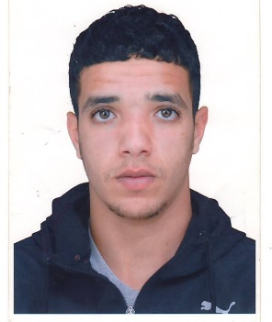**MAMERI NASRELLAH**

Date of birth: **27/02/2002**

Address : **Cité 900 logements entrée 82 N° 03 El khroub-constantine**

Nationalité : **Algérienne**

Tel : **0663.43.99.65 / 0783.15.58.26**

Email : [mamrinssrou@gmail.com](mailto:mamrinssrou@gmail.com)

Age : **22 ans**

Family situation:**Célibataire**

Military service: **Exempt**

Driving license**: B**

* ***Training and diploma :***
* Welder training Pipe-line A Lynatec-Batna
* Pipe welding ( soudeur de pipe-Line ) procédé S.M.A.W
* Basic Welding E7018 / Welding E6010
* 5G WAND
* MEULLEUR
* Sanitary and Gas plumber training 2018
* ***LANGUAGES***
* 02 years Metal frame welder (TUNISIAN COMPANY) at STEEL TRANS
* Constantine – 2019-2021.
* **08 months Molder at the private company BIDI NORREDDINE in Constantine**
* **(01Level) April 2, 2023 - November 10, 2023.**
* **02 years General Plumber and Gas – central heating installation 2021 -2023 .**

***LANGUAGES:***

* **Français :**Ecrit et parlé Moyenne
* ***Extra-professional activities :***
* **Dynamic, with a sense of responsibility and organization.**
* **Having a group spirit.**
* **Able to work day and night.**
* **Able to work at any location and able to travel anywhere.**
* **Being in very good physical shape and in very good health.**