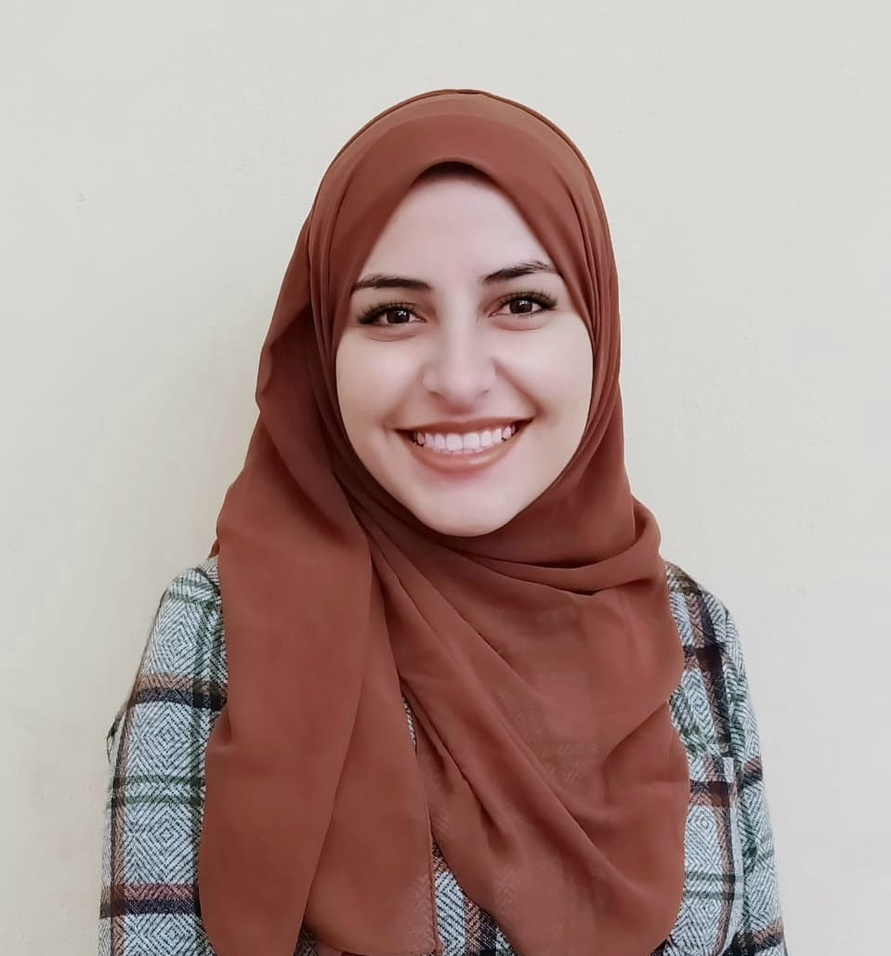**Address: Al-Ayaat, Giza**

**Mobile: 01141297387**

**E-mail: aya98elshazly@gmail.com**

**Aya Ali Mahmoud Ali**

|  |  |
| --- | --- |
| **Objectives** | Seeking a demanding position within a multinational  corporation to enhance my skills, and to improve my  knowledge and enrich my career path, I would like  to have the opportunity to expose myself to new  challenges by adding academic, practical knowledge and work experience. |
| **Summary of qualifications**  **Education**  **Skills**  **Professional experience**  **Competences**  **Courses** | **Special personal qualifications and skills:**   * Communicate effectively in both oral and written forms. * Good Leadership skills   Faculty of Tourism and Hotels, Helwan University  Tourism Studies Department. (English Section)  Graduation year : August 2020  Final graduation grade : **Excellent**  **Language Skills:**  Native language Arabic (Mother Tongue)  Very good in both written and spoken English  **Computer Skills:**  Good Knowledge of Microsoft office package (Word, Excel & Power Point) Internet.  **Other Skills:**  Good Knowledge of, faxes, printers, scanners ,special conferences & telephone communications, GPSs, video & digital cameras.  **Training Experience with Performed Duties:**   * ***Training at Misr Travel.***   **2019:**   * **1,Talat Harb** [misrtravel@link.com](mailto:misrtravel@link.com) * **Kemet** [kemet@misrtravel.com](mailto:kemet@misrtravel.com)   **2018:**   * **43 kasr El-Nil** [43kasrelnil@misrtravel.com](mailto:43kasrelnil@misrtravel.com) * Well-organized * High communication skills. * Self-motivated, reliable and goal oriented. * Professionalism in dealing with confidential information. * Ability to work well with all levels of management and personnel. * Good experience in conflict management. * **Public Service Personnel Program** |

**References**

**To Be Furnished Upon Request**.