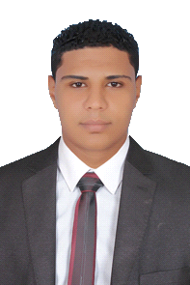

**- Name:**Ahmed Saeed Mostafa Mashref

**- Address:**El-Saff , Giza

-**E-mail:** aalhlwany15@gmail.com

- **Mobile:** 01016135139

**_Personal Profile**

**•Full Name:**  Ahmed Saeed Mostafa Mashref

**•Phone Number:** 01016135139

**•Email Address:** [aalhlwany15@gmail.com](mailto:aalhlwany15@gmail.com)

**•Date of Birth:** 1 August 1995

**•Nationality:** Egyptian

**•Address:** EL-Saff / Giza

**•Social status:** Single

**•Recruiting:** Military service was performed

**_Qualification/Education**

* **Name of certificate**: Information Systems and administrative
* **Graduation date: 2017**
* **Appreciation: Good**
* **Graduation Project Appreciation: very good**

**_Work Experience**

• Summer training in Nile Advertising Company for two years

• Current work Customer Service at Raneen

**.**Sales representative in United Pharmacy for two years

**_Skills**

**•Proficiency in dealing with computers and the Internet**

**•Dealing with Microsoft Office (word)**

**Other:**

•Ability to work under pressure

•Ability and speed in learning new work tasks

•Ability to solve and deal with problems

Previous work:

_Customer service at Raneen

Current work: Sales:

_ representative at the United Pharmacists Company