CURRUCULUM VITAE 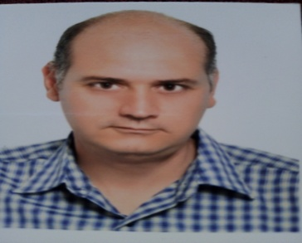

***Personal information:***

First Name/Surname: Bouabdallah Sami

Address: 29 avenue de l’Union, cite Enozha 2080 Ariana TUNIS

Phone Number: 97 68 40 20

Email: [bouabdallahsami2@gmail.com](mailto:bouabdallahsami2@gmail.com)

Nationality: Tunisian

Date of birth: 21/01/1977

Sex: Male

Family situation: married

Chidren: 01

***Personal Summary:***

I would like to use the knowledge I have acquired during my bioengineering studies for practical project such as project handling, repair and the commercialization of biomedical solutions.

I would like to be involved in roles which can gives me greater autonomy and to use my initiative as I believe I am ready to take on greater responsibility.

***Work experience:***

**PROMOCHIMIE (Bayer): 01/2002-04/2002**

- Examine mal functioning equipment laboratory, dear and defect.

- Test trouble shoot defects to determine correct repair action

- Install and demonstrate equipment operation and explain preventive maintenance to biologist staff and for service

**RECTA MEDICA (Stryker): 06/2003-03/2010**

- Preparing and submitting documentation in support of property and liability claims involving the facility.

- Reviewing and analyzing insurance premiums and recommends appropriate internal distribution among funding sources and monitoring and all others claims status.

- Maintaining relation with insurance providers and provide customer service.

- Verifies health care charge against established rate for diagnostic, treatment, service and supply.

- Responsible for trouble shooting, repair, installation and preventive maintenance: orthopedic instrument, endoscopy, power tools

- Done installation and training end-users to use the equipments and for service engineer.

- Participation in the congress in Tunisia

- Sale of medical equipment.

**BEST MEDICAL: 04/2010 -12/2010**

- Responsible for trouble shooting, repairs, installation, calibrate and preventive like ECG-EEG-Ultra sound.

- Service support Discussing service contract.

**PIMOS (ZEISS): from 02/2011**

- Agenda Management, relationship with customers and service provider, market research

- Examine mal functioning equipment for wear, dear and defect.

- Test trouble shoot defects to determine correct repair action

- Install and demonstrate equipment operation and explain preventive maintenance to medical staff and for service.

- Repair, maintain and calibrate different machine operating: microscope operating ophthalmology neurosurgery, LASER (YAG and ARGON), OCT, Visual Field, biometry…

- Participation in the congress in Tunisia and France.

- Participation in business development for sale promotion.

- Was involved in the promotion marking and sale of Carl-ZEISS equipment.

***Training:***

- In Germany: CARL ZEISS MEDITEC:

- Service and maintenance.

- Sale of medical equipment.

- In Dubai: 06/2003 STRYKER ENDOSCOPY

- Service and maintenance

- In Tunisia

- SIMEINS Health care:2001

- Hospital Abdurrahman Mami, Ariana.2000

E-learning

- HAMILTON MEDICAL: Ventilator System Concept, Basic Operation of Intellivent-ASV for HAMILTON-G5/S1

-PHILIPS: Introduction to SPO2

***Skill:***

Arabic – French – English