0
Personal Information
CURRICULUM VITAE
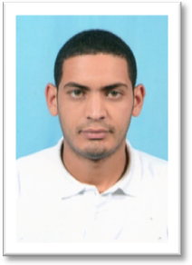
- Name : LATRACH
- Surname : Mohammed El-Amine.
- Date of birth: 16/01/1991 in Aflou, Laghouat.
- Address : District 23 housing, Aflou.
- Relationship : Maried
- Phone number : .0771 500 223 / 0552 26 24 12
- Email: latrachmed91@gmail.com
- Military service: Clear: Breadwinner
Training

- JUNE 2009: Baccalaureate in Experimental Science.
- JUNE 2013 : Licence in Hydrocarbons Option: Electrical engineering Industrial Electricity M’Hamed Bougara University– BOUMERDES-.
- JUNE 2015 : Master 1 in Hydrocarbons Option: Electrical engineering Industrial Electricity M’Hamed Bougara University– BOUMERDES-.
Professional experience

- Practical internership : SONATRACH - HASSI R’MEL.
- TEAM SOURCE PETROLEUM – HASSI MESSAOUD 2017-2019
- FLOORMAN RIG 27 – GWDC- 2017/2019- HASSI MESSOUAD
- Production team manger in mineral water factory 2019/2022

IT Tools

- Microsoft office (Word Excel Power Point).
- Programming: Pascal and Microprocessor: 8086.
- Software simulation: PSIM, et Matlab and Pispise.

Languages

- Arab: Very good
- French : Good.
- English: Good
Various

- Dynamic, serious and have the sense of responsibility
- Good physical condition.
- Have the spirit of the team.
- Drivers license available

