Name: Mohamed Ashraf Ragab Abd Alalim  Contact: Mobile: +2‏‪01014335584  ‬‏  Email : me040983@gamil.com  Address : Minya Governorte – Samalout Center | 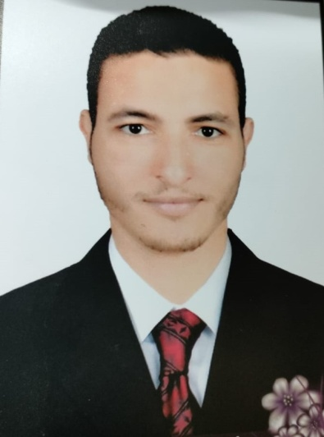

Career Objective | - Ability to continue serving patients  - Improving my skills and talents  - Keeping in contact with new humans and technical service providers from all over the world.
Personal Details | Birth : 01/04/1995 .  Religion : Muslim .  Nationality : Egyptian .  Marital Status : Single .  Military Service : Finished Military Service.
Education | - Technical Institute of Nursing, batch of 2015, with a grade of very good.
Work Experience | - ICU Stuff Nurse +Emergency + Supervisors :- {ICU * CCU * Post Open Heart Surgery} IN ( Suez Canal Hospital in Ismailia From 19/5/2016 Till Now ) .  - Operations Stuff Nurse + Emergency ( Alhaykistib Military hospital 1/12/2017 ) .  - Post Open Heart Surgery ICU ( Air Specialized Hospital From 1/10/2020 Till Now ) .
Languages  Work skills  COURSES | Arabic : Mother tongue.  English : Very Good written and spoken  - Excellent communication skills.  - Able to work under pressure.  - A confident and assertive nature.  - Computer : Good  - Infection Control.  - Basic Life Support.  - Qualityof traning.

