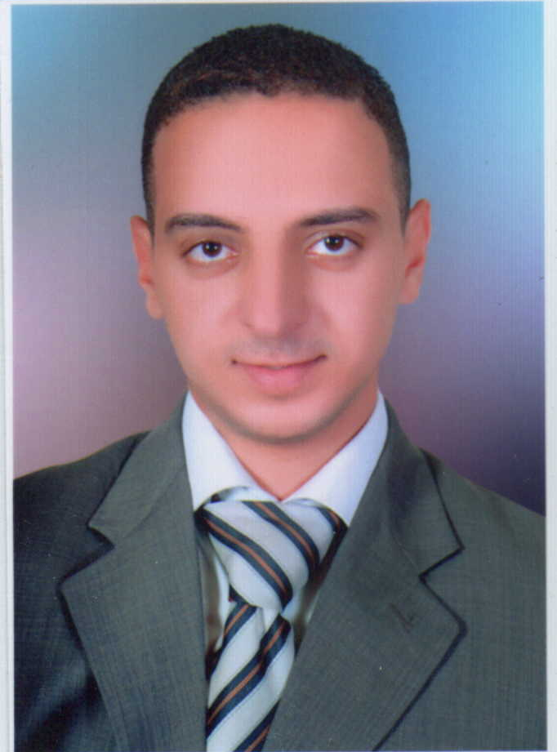
Curriculum Vitae

Mostafa Mahmoud Kotb Hassan

Objective:

Seeking a challenging position in a reputable company enabling me to utilize my academic background, interpersonal skills, increase practical experience, satisfy my ambitions and expand knowledge.

Education:

Bachelor of commerce – the dept of business administration with good grade from Workes University at June 2006

Work Experience:
- Administrator at Barakat Plaza Mall (from Jul 2020 until now)
- Sales Supervisor at GNEULABS for software Development (from March 2019 to May 2020)
- Financial Consultant at Allianz (from Nov 2017 to March 2019).
- Insurance agent at CHUBB life (from September 2016 to October2017).
- Warehouse Assistant at Al Rehab for modern carton and paper technology (from August 2015 to September 2016).
- Finance Officer at Assuit Businessmen Association (for 10 months) in Asyut.
- Cashier in " Al Watania Palace Hotel – Asyut" (for 10 months )
- Marketing Coordinator "El Fayroz for management tourism bazaar" co. which is specialized in the field of importing and selling of tourism product (for 4 years and 3 months) in Hurghada.

Training Courses:

Basic Business Skills Acquisition (BBSA) Program, sponsored by Future Generations Foundation (FGF), including:
- Business English.
- Business writing.
- Presentation skills.
- Computer skills (MS Office 2010, MS Project & Internet).
- Extra sessions for Accounting, Finance, Sales and Marketing.

Language Skills:

- Native language Arabic
- Very Good command of both written and spoken English

Computer Skills:

- Excellent Knowledge of using the computer and managing files Windows 7, Windows 8 and Microsoft Office Programs (MS Word – MS Excel – MS Access – MS PowerPoint – Internet and Information Technology.
- Very good typing skills ( Arabic – English )

Academic Studies

This includes the Human Resources Management Occupational Certificate (sponsored by CAME center) which made me have a lot of skills and excellent knowledge about:
- Strategic management
- Organizational structure design
- Job analysis phase
- Job description and specification phase
- Preparation of HR plan
- Planning HR recruitment
- Selection and interviewing phase
- Steps for hiring process
- Management of employees career path and promotional plans
- Training and development
- Training needs
- Methods of implementing and developing training programs
- Designing the structure of wages and salaries
- Calculating salaries' taxes
- Preparing payroll and accrual
- Teamwork skills and relationships in the work environment
- Communication skills and dealing others
- Stress management
- Assessing employment satisfaction
- Developing employee performance
- Safety and health program ( OSHA )

Personal Qualifications

- Excellent communication skills.
- Good at meeting deadlines.
- Creative, self-motivated, reliable and dynamic.

Hobbies

Surfing the internet& reading and traveling.

Personal Data

- Mobile Phone: 01068993614 - 01125742050.
- Address: 2th EL Mohandessin Street. – Assiut.
- Date of birth: 16/5/1984.
- Military Service: Exempted.
- Social status: married
- Email Address: mostafaelkharat1984@gmail.com

* This resume was last updated on Aug 07, 2021.

